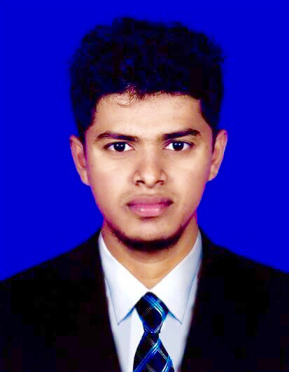
Musthafa

Musthafa.382086@2freemail.com

CAREER OBJECTIVE

To contribute to a dynamic enterprise offering adequate opportunities for career advancement based on skills, experience and merit, where my strengths can be exploit to optimal use for the development of the organization.

PERSONAL STRENGTHS

Hardworking, dedicated, adopting and sociable, can work under pressure with time bound performance, sincere and result oriented.

SCHOOL ATTENDENSE

- Al Aksha Central Collage – Kinniya, Sri Lanka.
- Passed General Certificate Examination Ordinary Level – 2008
- Passed General Certificate Examination Advance Level – 2011

EXTRA CURRICULAR ACTIVITIES

- Prefect – Al Aksha Central Collage, Kinniya.

- Member of School Volley ball & Cricket team.

PROFESSIONAL QUALIFICATION

- Completed a computer accounts clerk course at Data Information Bureau in Sri Lanka and Trained to the same position. (Well versed in MS office, Access data base, internet, email and some accounts edition etc.)

- Completed a Management Training Course at a Private Establishment in Sri Lanka.

- Successfully completed a cross Training course in Banquet, Ritz Carlton, Riyadh. KSA.

- Successfully completed a cross Training course in Laundry, Ritz Carlton, Riyadh, KSA.

WORKING EXPERIENCE:

- Worked as a Bellman in Ritz Carlton, Riyadh, Saudi Arabia (for 2 years) .
- Worked as a Repcetionist in 3* villa hotel in trincomalee sri lanka for 2 years.
- Worked as a bellman in bay la sun hotel in Jeddah KSA.

LANGUAGES:

- Able to read, write & speak English, Tamil & Sinhala.

- Able to speak Hindi & Arabic.

PERSONAL INFORMATION

• | Age | : 24 years
• | Date of Birth | : 28th of November 1992
• | Nationality | : Sri Lankan
• | Sex | : Male
• | Married Status | : Single

