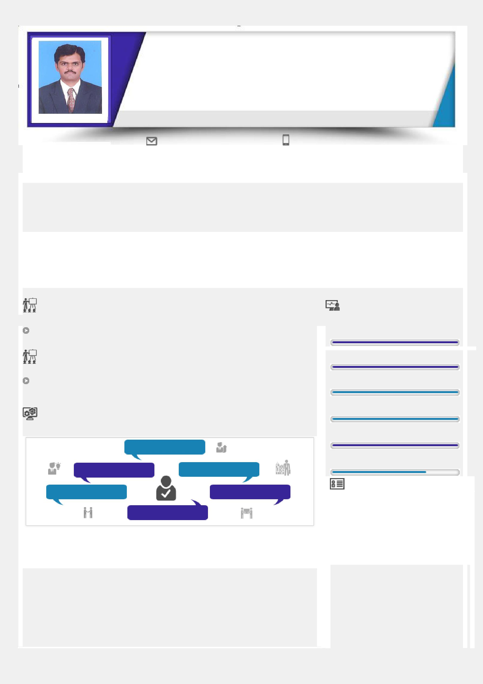
RAJEEV

Mechanical Engineer with 6+ years of experience in Production/Maintenance as Assistant Manager Production, and 2+ years of experience in Service logistics at Johannesburg - RSA, Worked and trained on SAP, AutoCAD2005 & Pro-E

Profile Summary

Location Preference: Any Where ~ Industry Preference: Mechanical

Rajeev.382093@2freemail.com

B.E (Mechanical Engineering) with Implementing effective solutions for product development, production management & operation management and co-ordination with internal departments. Analysis & reduction in cost of production by arranging in process materials on time with performance monitoring of vendors. By arranging materials, targets are achieved with proper utilization of resources to improve productivity. Identify and create a business process, which is a formalized set of tasks and activities that helps accomplish specific business objectives. Implementing risk management, value management and cost control measures by assisting vendors/ engineers for their doubts & arranging materials with maintained machinery for production.

Education
2006 B.E (Mechanical Engineering) from Maharaja Engineering College, Coimbatore, Anna University- Chennai
2002 Higher Secondary from C. M. S. Matriculation Higher Secondary School, Coimbatore

2000 Senior Secondary from C. M. S. Matriculation Higher Secondary School, Coimbatore

 | IT Skills |  |  |  | Area of Excellence
 | MS Office, SAP, AutoCAD, Pro/E |  |  |  | team Management
 | Academic Projects |  |  |  | Value Management
 | Design and Fabrication of Planetary Drive Slow Motion Gear Box at S. P. M. |  |  |  | Vendor Management
 | Industries, Coimbatore
 |  |  |  |  | Risk Management
 | Soft Skills
 |  |  |  |  | Reporting & Analysis
 | Team Player
 |  |  |  |  | Cost Control
 | Self confident | Active Listener

Resourceful Planner

Personal Details

Communicator

Name | : | Rajeev
Date of Birth | : | 24th May 1985
Languages Known | : | English, Hindi, Malayalam, Tamil
Nationality | : | Indian
Marital Status | : | Married
Driving Licence | : | India

Career Timeline

P S G & Sons Charities

(Metallurgy and

Foundry Division)

Ensure IT Services

(Group of Redington Gulf

India Ltd )

Maintenance Engineer

Senior Process Executive

 | Nov 2006 | Apr 2008 | Oct 2013 | May 2016
- | Feb 2008 | - Feb 2012 | – Apr 2016 | - Feb 2018
 |  | Transafe Services Ltd. |  | Premier Engineering
 |  | (Group of Balmer
 |  |  |  | Works
 |  | Lawrie & Co)
 |  | Assistant Manager |  | Assistant Manager
 |  |  |  | Production
 |  | (Production)
Previous Work Experience
Organization : Premier Engineering Works (From May 2016 to Feb 2018)
Position | : Assistant Manager Production
Environment : An ISO 9001-2008 company in manufacturing of Cast iron & Ductile iron components.

Role:

Production planning & execution Analysis of day to day problems

Managing sub-ordinates and monitoring performance, evaluation and work execution Analysis & reduction in cost of production
Rejection analysis and their rectification
Monitoring & Controlling the Labour & materials
Calculating the labour and materials requirement as per working schedule and ensuring availability of the same

Contribution:

Achieving production targets with proper utilization of resources to improve productivity

Implementing effective solutions for product development, production management & operation management Tracking the progress of work and reporting the progress on weekly basis
Successfully created detailed progress reports and analysed the reports for implementing control measures
Ensuring the quality of work as per the specifications required for cast iron components

Adhered to the safety rules as per safety standards
Record the quantity of work done daily for monthly costing to analyse and reduce the rejection in casting

Organization : Ensure IT Services (Redington Gulf India Ltd) – Johannesburg RSA (From Oct 2013 to Apr 2016)
Position : Senior Process Executive

Environment: Authorized Service Provider for main brands HP, ASUS, DELL, TOSHIBA and LENOVO Role:

Service Support Analysis, Managerial and Defective management

Evaluate, Design, Execute, Measure, Monitor and Control Business processes

Analysing the labour reports and identifying various areas for profit/loss and recommending Control measures such as labour reduction, material wastage etc. to reducing losses/ maximizing the profit

Contribution:

Identify and create a business process, which is a formalized set of tasks and activities that helps accomplish specific business objectives
Maintain logistics department to make inward, GRN & issue of parts to Engineers in system & physically.

Introducing innovation into the process that will impact results, enhance profitability, and assist the organization to

consistently meet its business objectives and goals.

Company been a Authorized service Provider for brand such as HP, ASUS, DELL, TOSHIBA, LENOVO need to send defectives back in allocated time provided, as not to get debited.

Attend international conference by phone with HP Top management regarding business outcome. Responsible to ensure that business process outcomes are in harmony with an organization's strategic goals

Organization : Transafe Services Ltd. (Balmer Lawrie &Co) (From Apr 2008 to Feb 2012)
Position : Assistant Manager - Production

Environment: Manufacturing, Fabrication & Furnishing in-house & Transportation Containers and Bunk-houses

Role:

Arranging & Guiding the vendor to produce quality assured Containers/Bunk-houses Assisting Production Engineers on container drawings, BOM

Using SAP packages for Purchase order [PO], Transfer Posting & Goods Received [GRN] making, as to show the materials issued / obtained for the process

Contribution:

Follow material suppliers & product manufacturer to speed up & deliver product on time.

Maintain auditing records for ISO: 9001-2008 & OHSAS: 18001-2008 certification from TUV for Production and maintenance

Carry fabrications, assembly of products as per approved drawings & procedures.

Strictly Assist Vendors to follow up and produce containers through Lean Manufacturing (5s) & Kaizen in-order to reduce waste in production process.

Assisting Vendors & Production Engineers for their doubts in approved Containers drawings to produce finished goods/containers on time.

Overall shop floor in charge of setting & achieving various targets by continuous improvement.
Product quality improvement at inward, in process and delivery.

Organization : P S G & Sons Charities (Metallurgy and Foundry Division) (From Nov 2006 to Feb 2008)
Position : Maintenance Engineer

Environment : Foundry maintenance of 125 HP Screw & Reciprocating compressors, High pressure moulding machine – DISA MACHINE, Jolting type moulding machines, Shot blasting machines with the capacity of 1.0 ton, 1.0 ton main frequency furnaces, 3.5 ton medium frequency furnaces, Tm 160 mixer with the capacity of 500 kg.

Role:

Contractors Handling, Scope of work, performance monitoring, evaluation and work execution

Contribution:

Break Down maintenance analysis & corrective actions

Preventive, Predictive, Facilities and Utility maintenance for planning & execution

Maintaining & enhancing the performance moulding machines, shot blasting machines, Furnaces and EOT cranes including Machine calibration activities
Providing uninterrupted services of utility equipment's

Quality System ISO 9001, ISO14000 system adherence. Spares parts planning, procurement and storage management.

DECLARATION

I hereby declare that all the details furnished above are true to the best of my knowledge.

Place: | Sharjah | Yours Sincerely,
Date : |  | (Rajeev R).

