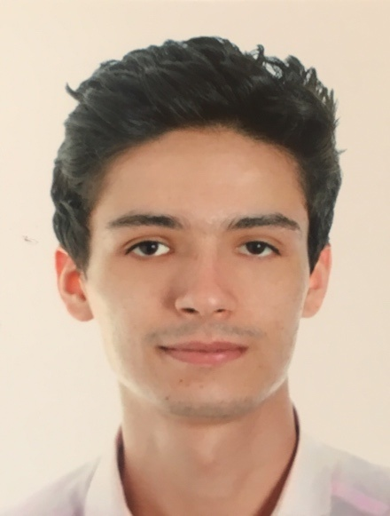

Abdelillah

| abdelillah.382104@2freemail.com | 22 years old | Moroccan nationality.

Formation
2014 : Baccalauréat in Economic Sciences at Assabil School.
2015 : Integrated the Faculty Mohamed V – Agdal of Economic Sciences and Law Studies for one year.
From 2016 to 2018 : Moved to the International University of Rabat to study Business Law during 3 years.
2018 : Obtained my Business Law degree and officially became a Legal Lawyer in Business Law.

Experience

- 2nd of the promotion during the Academic Year 2016/2017.
- Selected for a Erasmus+ mobility exchange at the University of Málaga in Spain for 6 months (Instruction Language : English only). 2017/2018
- June to July 2018 : Internship in the legal department of CDG Development in Rabat as Legal Lawyer
- Member of a non-profit association whose goal is to protect women from all types of discrimination.

Competences
- Language Skills :
- English (fluently),
- French (Native),
- Arabic(Native),
- Spanish (Basic).

- Optimist, dynamic, and patient.
- Positive and focused on my work.
- Love kids !

