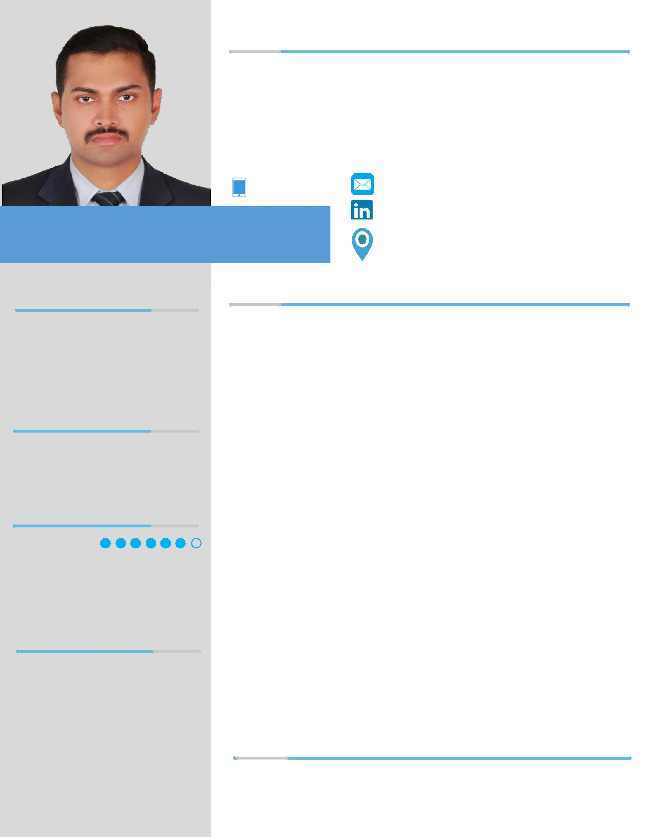
P R O F I L E

I am a B.Tech graduate in ECE with 2 years of Gulf Experience in UAE as an Electrical Engineer and an overall career experience of 5 years. Throughout my career in UAE, I had gained experience in various electrical installation and maintenance projects while handling the role as a Site Engineer as well as Supervisor. My greatest quality is the sincerity and dedication to the work and other responsibilities. I have the confidence to lead and guide a team for accomplishing the works.
Susil.382112@2freemail.com

S U S I L T H O M A S

P E R S O N A L D A T A

DOB – 21. 05. 1988

NATIONALITY – INDIAN MARITAL STATUS – SINGLE

E X P E R I E N C E

POWER LINKS QATAR CONTRACTING, ABUDHABI

2017 | PLQ Contracting is specialized in the field of high voltage installations
JAN | and testing services in GCC.
|
 | Designation: Electrical Engineer

P A S S P O R T D A T A

PASSPORT No. – K 6 1 6 6 9 6 2 EXPIRY DATE – 22. 11. 2022

L A N G U A G E S

| | Al Maryah Central Project:
|
| | 400/220/33KV Grid Station,
 | Mirfa
| | Emirates Steel Industries,
| | Mussafah
2014 | EBGC Project, Bab-Habshan
DEC

Site Engineer for LV Cable Laying; Module, Panel & DB installations at Abu Dhabi City.

Site Engineer for 33 & 220KV Cable Laying, cable testing & earthing works

Site Engineer for LV Cable Laying & testing, Tray installation, Lighting pole erection, DB & Panel

Worked as a JOB PERFORMER and supervisor for 33KV under-ground Cable Laying and Testing.

ENGLISH –

MALAYALAM – HINDI – TAMIL –

S K I L L S

SAP BUSINESS ONE – MS EXCEL – MS WORD –

MS POWERPOINT – PHOTOSHOP – WINDOWS –

NORTECH INFONET PVT. LTD. KERALA, INDIA

2014 | Nortech Infonet Pvt. Ltd is an authorized partner of SAP
OCT
| | Designation: Administrator – SAP Business One (ERP-CRM)
| | SAP BUSINESS-ONE Software Trainer
2012 | Data Migration (DTW) in SAP: Experience in Sales, Purchase,
 | Accounts & Inventory
DEC

PEARSON PVT. LTD. KERALA, INDIA

2012 | ------ 2011 | Work Coordinator for Cable and OHL Installations and
DEC | DEC | Computer data updating.

C E R T I F I C A T I O N S

- SAP Business One Functional Consultant(ERP-CRM)8.8 version

- ADCO Approved Job Performer & GASCO Approved PICWS.

E D U C A T I O N

P R O J E C T S

T R A I N I N G S

H O B B I E S

Qualification | Year Of | Institution
 | Passing
B.Tech | 2012 | SNMIMT, Maliankara
 |  | MG University
 |  | 56.82%
HSE | 2006 | Govt. Higher Secondary School, Chendamangalam, North Paravur
 |  | Board of higher secondary examination, Kerala
 |  | 67.83%
SSLC | 2004 | S.T.Aloysius High School, North Paravur
 |  | Board of higher secondary examination, Kerala
 |  | 61.66%
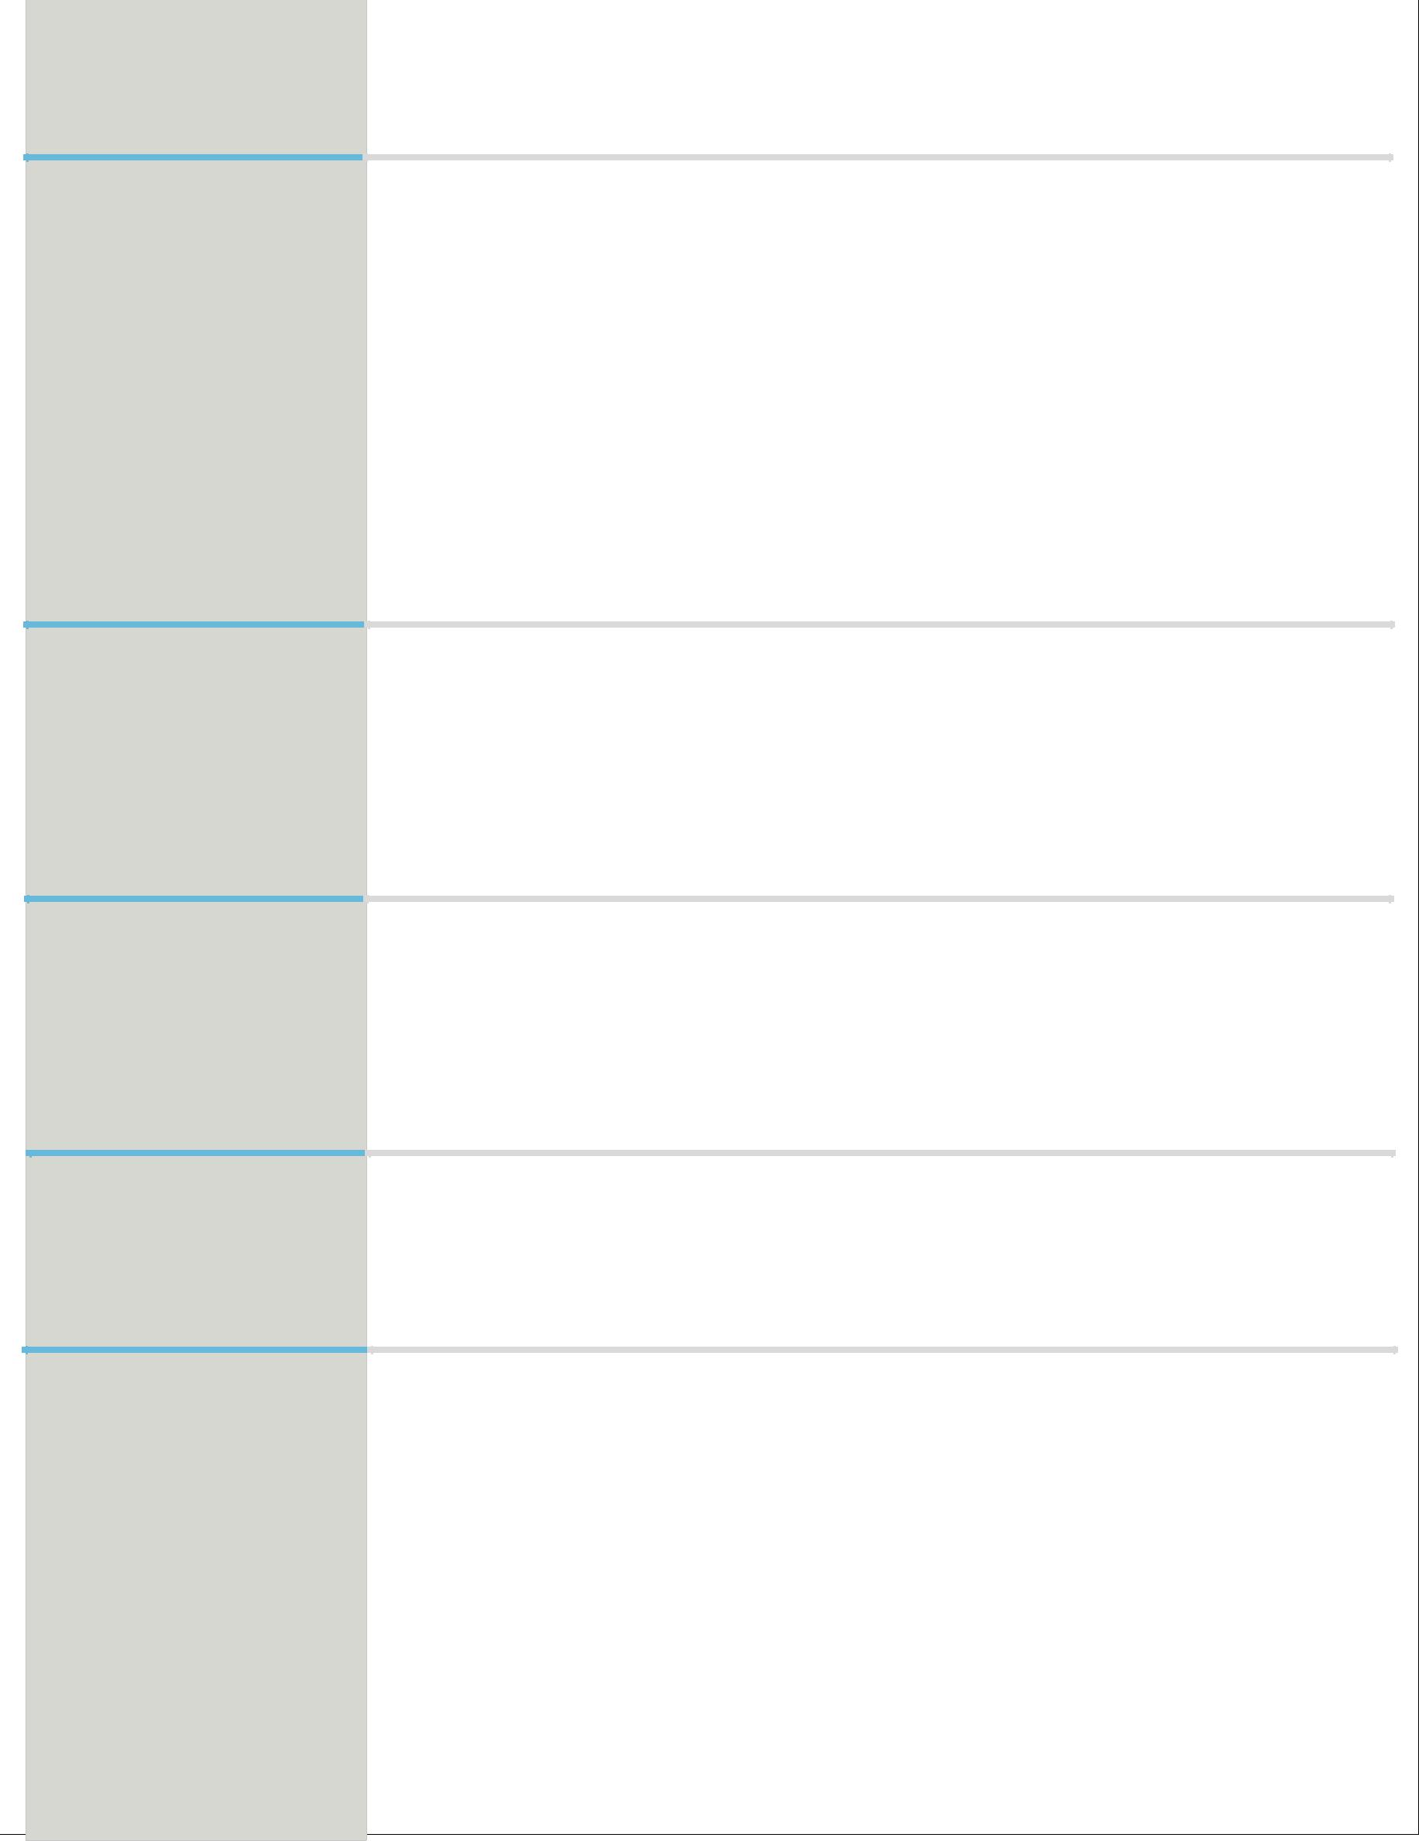

  - Main Project (SAP): Accelerated Implementation program on “KPL Oil Mills Pvt. Ltd”.

  - Main Project (B.Tech) :Human Interacting Device with Bluetooth for Disabled

  - Mini Project (B.Tech) :Versatile Mobile Phone Charger

  - Seminar Topic(B.Tech): Ultra capacitor

- Course in Familiarization of “Automation Technologies” conducted by the training centre of SMEC Automation Pvt. Ltd. Cochin.
- Participated for a technical workshop on “Embedded System” organized by the

Cochin training division of ACCEL IT Academy

- Reading

- Listening Music

- Playing

D E C L A R A T I O N

I hereby declare that all the above mentioned information is true to the best of my knowledge and belief. I request you to be kind enough to give an opportunity to serve your esteemed organization in the capacity mentioned above, for which act of kindness, I shall be very thankful and grateful to you.

Place : Dubai
SUSIL

