Zain
Zain.382143@2freemail.com

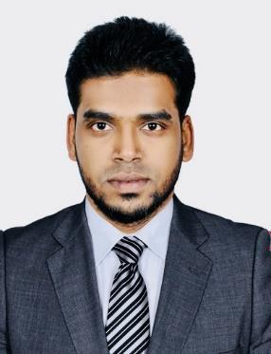

Summary

• | Profile: | Male, 31, Married
• | Nationality: | India
• | Current Location: | UAE, Dubai
 |  | (Visit
• | Driving License: | Issued in Saudi Arabia
• | Current Position: | Branch Manager
• | Company Name: | Global Inox Tech Steel Technology Co
 |  | (Reporting to Operations Manager)
• | Notice Period: | Available Immediately
• | NOC Requirement: | None
• | Preferred Location: | UAE
• | Current Salary: | Will provide on request
• | Expected Salary: | Negotiable

Work Experience

Mar 2017 - Present Global Inox Tech Trading Co Ltd Riyadh, Saudi Arabia

Branch Manager

The company based on trading of pipes, valves, flanges, pumps, fittings, sanitary valves (Alfa Laval) and consumables. Their major clients all are Food & Beverage companies. I am responsible for:

- Monitoring Showroom Sales

- Market Analyzing

- Showroom Organizing

Page 1 of 2 Zain’s CV

May 2012 - Feb 2017 Tetra Tech Co Ltd Riyadh, Saudi Arabia

Sales Manager

The company was active in trading and contracting of industrial supply. And they manufacturing stainless steel silo’s, tanks and lighting poles. Installing filling machine, pipe line, chiller and boilers. the company has excellent project team and sales team. their major clients are Al-Marai, Al-Safi Danon, Nadec, Pepsi (Bhukshan), Arrow Beverage, Henkel, Coca Cola etc.

I am responsible for:

- Build and develop showroom sales

- Managing team of 12 salesmen to achieve targets

- Monitoring stock availability, orders and shipments

- Inventory control

Education

May 2007 - Jul 2010 Indian School of Management and Technical Studies

Karnataka, Bangalore, India

Business Administrations, Bachelor(BBA)

Languages

• Tamil: Native

- English:Working Knowledge

• Arabic: Working Knowledge

• Urdu: Working Knowledge

- Malayalam: Basic

Page 1 of 2 Zain’s CV

