VENKATESH
EDUCATION
2017 – Present Amity University, Dubai, U.A.E. MBA(Master of business administration) in Construction and Project Management.
2013‐2017 Sathyabama University, IndiaBachelor of Engineering in Civil Engineering.
PROFESSIONAL EXPERIENCE

PROJECT WORKS UNDERTAKEN
Landslide hazards & its preventive methods by using ARCGIS Software at University 50M Tower facility.(April 2017)

Work Scheduling activities of a Residential building (G+Podium+5 floor project ) by using Primavera P6 software (MAY 2018)
EMPLOYMENT HISTORY
TRUCKERS CARNIVAL, ABU DHABI 22 MARCH to 30 MARCH 2018
- Receive payment by cash, check, credit cards, vouchers, or automatic debits.
- Issue receipts, refunds, credits, or change due to customers
- Count money in cash drawers at the beginning of shifts to ensure that amounts are correct and that there is adequate change
F1 RACE VOLUNTER IN ABU DHABI Nov 25 to Nov 28 2017
- From handing out race kits before the race starts to making sure drivers stay hydrated on course to congratulating participants with medals at the finish.
- provides a practical walkthrough of the procedures and schedule of activitiesbut the experience is priceless
BHAGAVATHY CONSTRUCTION, CHENNAI. MARCH 2013- June2014
MARKETING EXECUTIVE :
- Responding the mails from the property based websites , contacting the interested clients who is looking for the apartments
- Promoting the project to the client and analysing the needs , requirements for improvisation in future projects
- Visiting the suppliers and providing the payments for the supplied goods

.

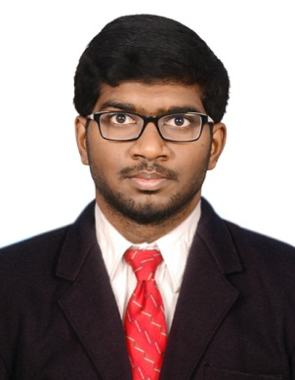
CONTACT DETAILS

E-mail: venkatesh.382150@2freemail.com

PERSONAL DETAILS

Nationality: Indian
D.O.B : 01/ June/1995
Visa : Student Visa (2019)
LANGUAGES KNOWN

English : Fluent

Tamil: Fluent
French : Fluent
Hindi : Intermediate

COMPUTER SKILLS
SOFTWARE:AutoCAD,STAADPRO, MS Office (Word, PowerPoint,Project),PrimaveraP6,Photoshop..

SPORTS/HOBBIES

- Badminton.
- Roller skating.
- Photography.
- Travelling.
- Writing.

