Rami Email: rami.382166@2freemail.com
- Industrial Engineer
WORKING & INTERNSHIP EXPERIENCE
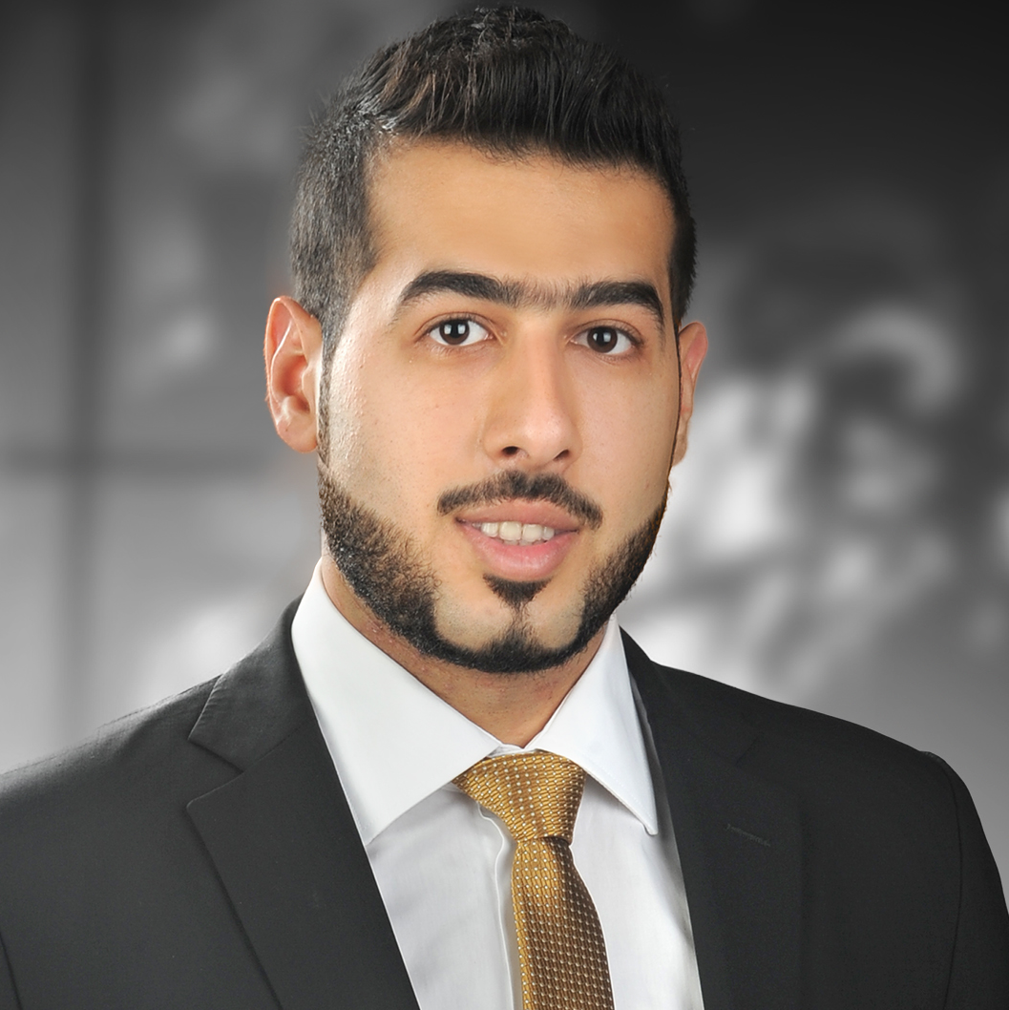

OBJECTIVE
Seeking an Industrial Engineer position were my skills and knowledge will have important utilization for the development of organizational productivity and to grow in a professional atmosphere where most of my skills will get utilized to the fullest and help me adapt to the dynamic environment.

STRENGTHS
- Leadership
- Teamwork
- Strong Work Ethic
- Problem- solving & Decision-making
- Organize, plan & prioritize work

OTHER SKILLS
- MICROSOFT OFFICE
- SPSS
- AUTOCAD
Verger Delporte U.A.E LTD Aug, 17 - Present
Business Development & Project Support
Working in the Extra Low Voltage (ELV) Department, manage the development of tender proposal and completion of tender documents, support the department head in attending sales meetings with client and support in the negotiation process. Attending sites visits to regularly support the project team, attending project progress meetings with clients, monitoring and collating project progress information, update project progress report and present to manager.

NAFFCO (INTERNSHIP) June – Aug, 2016
Design Department:
Attend meetings with sales & procurement teams to obtain information on customer expectations. Collect/review components catalog as per order. Develop design deliverables list and delivery program. Assign design work and monitor progress. Carry out calculation check based on safety standards. Design vehicle in accordance with the US/EN standards.
Production Department:
Establish fabrication and assembly project timeline. Review incoming workshop details. Inspect components for compliance to order. Review order for new and irregular components. Distribute fabrication and assembly work. Arrange sequence of assembly. Resolution of system assembly issues. Order parts from inventory.
Quality Control:
Inspect delivered parts in compliance to Specifications, Quality, and Sizes…etc. Check work in progress; for dimensions. Conduct Final Inspection of completed/assembled vehicle.

UNIVERSITY GRADUATION PROJECTS:
INVESTMENT ANALYSIS (ZOO PROJECT) SPRING (2016)
Set project timeline, Identify project landmark location, Obtain Municipality acceptance, Cost analysis, set the ZOO facility as per EU Standards, Develop Importing permissions tracking schedule, and set facilities and services.
CUSTOMER SATISFACTION IN BANKS: FALL (2016)
Set a target of customers, pick important questions, distribute 300+ surveys, and update survey on SPSS program, do the statistics according to most important questions, analyze and find a suitable conclusion to improve customers satisfaction.

Rami
- Industrial Engineer
SUMMER WORK EXPERIENCE (PART TIME JOBS)
Abu Dhabi Sustainability week Abu Dhabi
Masdar city (adsw) jan 14 - 18, 2018
- Manage communication with promotion company office.
- Monitor executive communication with public.
- Attended front desk customer relations.
World Parachuting Championships Mondial 2012 Dubai Mall, Dubai
Promoters Team Lead Jul 8-Aug 20, 2012
- Manage promotion gifts stock and distribution.
- Order of promotion gifts based on forecasted distribution.
- Manage communication with promotion company office.
RTA Mobility for All Dubai Mall, Dubai
Promotion Executive Jul 4 To JUL 6, 2012
- Lead a team of promotion executives in promotion stand.
- Manage promotion gifts stock.
- Monitor executive communication with public.
Ski Dubai M O E, Dubai
Customer Relation Jun 15-30, 2012
- Attended front desk customer relations.
- Direct customers through registration and to next destination.
EDUCATION
Bachelor of Industrial Engineering 2013 - 2017
(Industrial engineering is concerned with manufacturing and production systems, continuous focus on process improvement, development of efficient ways to use people, machines, materials, estimate production cost, supply chain, problem solving, , cost analysis, quality control, inventory management, business development, statistical analysis, operations management, interpersonal communication.)
Girne American University, Girne, North Cyprus
High School Diploma 2009 - 2012
Al Mawakeb School, Dubai, UAE
PERSONAL DATA
Nationality Jordanian
Date of Birth May 28, 1994
Driver License Valid UAE Driving License
Personal Activities Bodybuilding, football, Billiard

