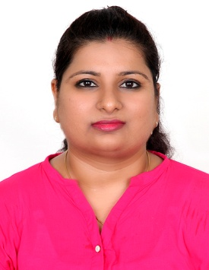

dimple
Dubai UAE
Email: dimple.382200@2freemail.com

To secure a challenging career with Dynamic, Servicing, Progressive organization in order to utilize my abilities, knowledge and personal acumen and with integrity contribute in the development

KEY SKILLS

Office Skills: | Office Management  Records Management  Database Administration | Calendaring  Deadline-Oriented  Confidentiality | Attention to Detail
Computer Skills: | MS Word  MS Excel  MS PowerPoint

Professional Experience

Worked as a Admin cum Personal Assistant in Aditya InfoTech(CPPLUS), Dubai , Dec2017 – May 2018

Admin cum Personal Assistant
- Handling all admin related issues.
- Type correspondence, reports and other documents
- Manage database of employees and clients.
- Assisting with all aspects of administrative management
- Coordinating between staff, labors and drivers in resolving day-to-day administrative and operational problems
- Scheduling and coordinating meetings, interviews, events and other similar activities
- Sending out and receiving mail and packages. Sending faxes, Managing Files
- Preparing meeting minutes, meeting notes and internal support materials.
- Client Satisfaction Surveys.
- Payment Follow Ups & Collections. Raising Invoice
- Answer a multi-line switchboard quickly.
- Screen, assess and refer individual inquiries to their destination. Taking down and deliver messages accurately and in a timely fashion Keep up to date information regarding the various events and happening at INDEX
- Perform general backup clerical support whenever needed
- Perform other related duties as required
- Maintains cleanliness and appearance of reception area
- Able to work as a team player in a changing and growing environment
- Greet customers and visitors to the premises, answering questions, announcing calls or providing directions.
- Able to respond to queries in a positive, pleasant, helpful and open manner.
- Organize and prioritize work, work independently, and multi task.
- Receive, sort and distribute incoming mail.
- Liaise with various dispatchers to ensure the timely delivery of documents and invitations.

- Education
- Higher Secondary Schooling In Arts
- Graduation In Arts from university of Kota, Rajasthan
- Master in Social Works from university of Kota, Rajasthan

Strength & Abilities

- Commitment towards job
- Hardworking, Sincere & Dedicated
- Result – Oriented & Self Innovative,
- Regular in matter of attendance. (100% of schedule attendance)
- Like to accept any challenge with positive attitude.

Personal Particulars

- Date of Birth: 13 February 1987
- Marital Status :Married
- Nationality: Indian
- Languages Known: English & Hindi
- Visa Status: Husband Visa

