PEACE

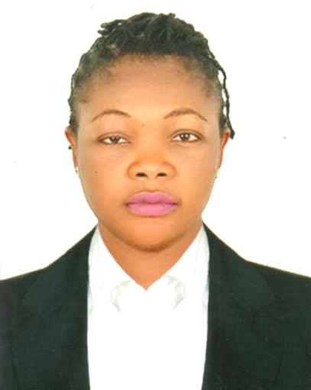

PERSONAL DETAILS

Date of birth
May 13th 1989

Gender
Female

Marital Status
Single

Nationality
Nigerian

Visa Status
Visit Visa

Languages Known:
English, Arabic

Email: peace.382218@2freemail.com

Position Desired: massage
Job Objective
Seeking a challenging position in an organization where I can utilize my experience to carrying out assigned duties effectively and efficiently and add value to the current services offered to customers
CAREER HISTORY
LASHI SPA AND FITNESS CLUB , LAGOS, NIGERIA
Durations: Jan 2016- JAN 2018
Position: Massage & Body Therapist
Duties and Responsibilities:
- Apply finger and hand pressure to specific points of the body.
- Assess clients' soft tissue condition, joint quality and function, muscle strength, and range of motion.
- Confer with clients about their medical histories and any problems with stress and/or pain in order to determine whether massage would be helpful.
- Develop and propose client treatment plans that specify which types of massage are to be used.
- Massage and knead the muscles and soft tissues of the human body in order to provide courses of treatment for medical conditions and injuries or wellness maintenance.
- Prepare and blend oils, and apply the blends to clients' skin.

Beauty “U” Spa, LAGOS , NIGERIA
Durations: APR 2014 – MAY 2016
Position: Massage Therapist
Duties and Responsibilities:
- Welcome clients to the spa and engage them in conversation to determine the services that they need
- Interview clients to determine of an illnesses or medical conditions that they may have which will keep them from taking proper benefit from massage treatments
- Provide clients with knowledge of different types of available massages and suggest appropriate massage therapies for individual clients
- Explain massage procedure and provide information about oils and creams used during massage
- Perform massaging activities according to each client’s instructions (pressure and preferred oil / cream)
- Talk to clients (minimally) during massage treatments to ensure their wellbeing during the procedure
- Use aids such as infrared lamps, ice and hot or cold compresses to help with massage therapies

ACADEMIC QUALIFICATION
- Certificate in Massage and Body Therapy, Lashi Spa & Fitness Club
- Completed Higher Secondary School Certificate

Skills
- Able to work as part of a team or independently with little or no supervision
- Flexible and can be able to work in a multicultural environment
- Superb interpersonal skills and exceptional ability towards greater customer satisfaction
- Excellent communication skills
- Computer literacy
- Ability to work under pressure

Strengths
- Self motivated and ability to communicate with other staff and motivate them
- Problem solving and decision making
- Good Analytical skill and a Quick Learner
- Focused on minute details

References
Can be provided upon request

