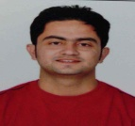
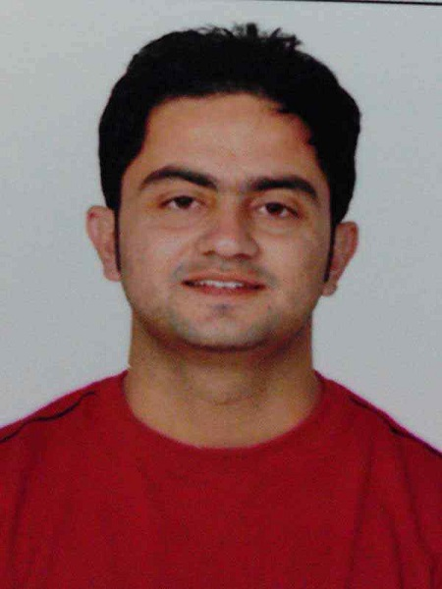

NAVEEN
: naveen.382241@2freemail.com

SENIOR EMBEDDED/ELECTRONICS ENGINEER
~ Embedded software/hardware development ~ Business Development Management ~ Client Management
Acknowledged for strengthening companies to lead in highly competitive markets & delivered innovative technical solution

PROFESSIONAL SNAPSHOT
- A “Performance Driven Engineer” bringing in business acumen developed in over 8 years’ of extensive experience in managing Embedded software/hardware development with an aim to accomplish technical plans. Used instincts, insight & judgment to succeed on tough deal:
  - Client Management focusing on maximizing customer satisfaction and process compliance.
  - Product Development to develop software/hardware whatever is client requirement.
- Design and develop automated unit, component and system tests in parallel with product software development. Execute automated and manual exploratory tests
- Assist software platform architects and other developers and technical writers in creating software platform documentation.
- Assist software quality assurance team members in creating and evaluating software testing plans.
- Develops firmware for new measuring / positioning tools for the construction industry in an internationally distributed team.
- Work with software development partners on planning, execution, release, and integration of third party software components
- Support the development of assigned task planning with Program Management .
- Firmware Development using Microcontroller coding Arduino, 8051, PIC applications using LCD, Motors, Sensors, ADC, ECU, GSM Modules, DTMF, and Touch switch.
- Hands on Experience in Developing Microcontroller Applications using sensors, LCD, Keypad, DTMF, Motor (DC, AC, BLDC), GSM(DTMF) & GSM Module, RF(Radio Frequency) etc.
- Hands on Experience in Assembly Language, Embedded C and Ladder Programming (PLC).
- Hands on Experience in Hardware designing software like ORCAD Deigning, Proteus.
- Hands on Experience in working in software’s like Kiel, IAR, Edsim, Topview, LOGO (PLC), AutoCAD.
- Knowledge of Analog and Digital Circuits.
PROFESSIONAL SNAPSHOT
Team Leading  Business Development  Client Management  Understand client requirement  Interfacing Hardware device  LEADERSHIP | CCTV  Networking  PLC  Embedded  System  Team  Leader  Software and Hardware Development  Product  Development  Training/  Development  Client  Management  Business  Development
.

SECURITY

AUTOMATION

AUTOMOBILE

CERTIFICATIONS  - Completed certification in:  - Business Development Management from Tech. Point India  - Advance Embedded System Edx | ACADEMIC CREDENTIALS  - M.Tech ECE (Pursuing) from Ramgarhia Institute of Engineering and Technology (RIET) from 2015  - B.Tech (Electronics and Communication) from Punjab Technical University (PTU) in 2010  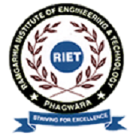
EMPLOYMENT CHRONOLOGY
Since May’ 2012 Tech. Point India, Punjab(INDIA)
Sr. Embedded Engineer/ Business Development Manager- Electronics Technology (Consultant)

- Spearheaded commercial as well as Government and Defense project (Indian Army, Air Force & Navy) India.
- To look forward the ongoing R&D project of the company and maintain the Quality and take care of Training Department.
- Drove business strategy to maximize sales and retention of commercial accounts nationwide.
- Improved current product of client by cross examination and implement requirement of client.
- Developed and deployed quarterly and annual plans, programs and policies for company technical teams.
Project:
1. Electric Car
Summary: In this project develop whole car for demo purpose. We design and develop this car for one of the emerging Automobile company. I was team leader of this project. I design whole layout of project and finally able to complete this project with my team.
Responsibility: As a team leader.
2. Prototype of drone Car
Summary: In this project we made a prototype of Drone plane but as a Drone car. In this project we use RF+ IR+ Laser Technology to control the car. The main advantage of this car this work automatically as well as manually too.
Responsibility: As a team leader.
3. Hybrid Car
Summary: In this project we use self made ECU which control the drives the motor when it required some torque when engine feels some load on particular rpm.
Responsibility: As a team member. I am actively involved in different modules of designing, coding.

Sep’11 to Apr’12 with CIHT(MSME) Jalandhar(Govt. of India Firm)
Engineer Trainee
- Imparted training for the corporate partners and students guided them in electronics and automation(PLC).
- To look forward the ongoing R&D project of the company and maintain the Quality and take care of Training Department.
- Assist scientist and senior engineer in government aided project
- Developed & executed customer level engagements that maximized entire customer lifecycle value.
- Program PLC for different company on demand
- Guest lecture on job oriented programs like Robotics, Embedded and on PLC on different Universities and Colleges
- R&D on new customer requirement.

Aug’10 to Aug’11 with INVENTORS Jalandhar(INDIA)
Electronics Engineer
- Work on Outsource electronics and Robotics project
- Assist senior engineers on outgoing projects
- Arrange meeting between client and company
- Learn basics of Business development Management
- Program PLC for local Vendors
Projects
1. Wireless Automatic Water valve System
Summary: This project is designed for the famous Sanitary Company of INDIA. In this project we wirelessly maintain 12 Electronics Water valve through RF remote.
2. Accelerometer based Defense ROBO Car with US Sensor
Summary: This project is designed for the Engineering Students in which we design a ROBO car which will according to Human Motion and the motion car is controlled by accelerometer which is further digital signal is transmitted by RF to ROBO Car.

PERSONAL SNIPPETS

Date of Birth: 03 October 1987Languages Known: English, Hindi & Punjabi
Nationality: India Driving License Details: Indian
Location Preference: UAE, Qatar, Bahrain, Oman & India

