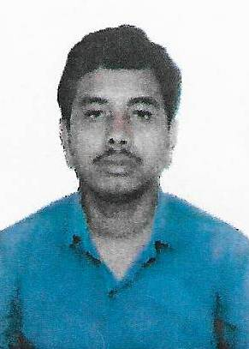
GOPAL
E mail: gopal382243@2freemail.com
Dubai - U.A.E.

POST APPLIED FOR: ASSISTANT CHEF
Objective:
To excel in a suitable position with my qualification and experience and to strive towards fulfilling the responsibilities assigned to me. I assure to uphold the quality standards and policies of a company. I am a good team player and enjoy problem solving

Personal Skills:
- Alp Good team player.

Work Experience:
- Presently worked as a
- Training Attended
Sagar International Hotel - Luck now in 2014 .

- Worked as a Chinese Cook with Sagar International Hotel, in Luck now, From Feb 2015 to April 2016.
- Worked as a Chinese Cook with Tuli international Hotel in Nagpur, May 2016 to March 2017.
- Worked as a Chinese Cook with Green Chilly Restaurant, Kolkata, from April 2017 to December 2017.
Personal Particulars:
Nationality India
Gender Male
Date of Birth 31/03/1994
Marital Status Married
Education 12th Class
Languages Known : English, Hindi and Bengali

Passport Details:
Date of Issue 11/07/ 2017
Date of Expiry 10/07/2027
Visa Status Employment Visa

Declaration
I do here by declare that the details furnished above are true to the best of my knowledge and belief.

