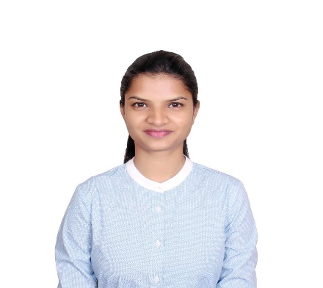
SAMPADA
Sampada.382248@2freemail.com
Summary
Professional and focused Auto Cad Drafter with a streamlined and efficient approach to client service. Adapt at adjusting work pace to meet evolving client needs and changing deadlines. Hands-on and detail-oriented whether working independently or as a part of a team.
Employment History
CHEMIONIX PVT LTD May 2016 – July 2018

AUTO CAD MODELER

- Drafting Smart P&ID's in Auto Cad P&ID software.
- Developed CAD drafts in Plant 3D based on project design requirements.
- Analysing 3D Civil & mechanical drawings and converting them in 2D.
- Preparing 'Paper to CAD' i.e. rough sketches, interpreted specifications to develop 2D drafts.
- Coordinated with Engineers to develop engineering change notices.
- Undertaking multiple projects at the same time and completing them effectively.
- 100% Quality Control of data before submitting for client approval.
Education
Gupte Institute - Training Mechanical Structural Drafting , January 2016Mumbai

HSC, January 2013Mumbai University

SSC, Graduated January 2011Mumbai University

Professional Skills
- Experienced in preparing Auto CAD drafting for 2D & 3D projects.

- Good knowledge of Piping and design principles.

- Sound understanding & knowledge of reading Architectural drawings.

- Mentored and provided training to junior drafters.

