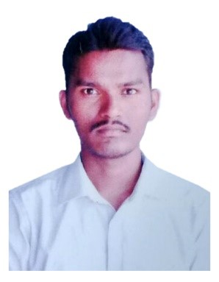
CURRICULAM VITAE

Pakala

Civil Engineer

E mail: pakala.382255@2freemail.com

Visa status: visit visa

CAREER OBJECTIVE:

To work in a firm with a professional work driven environment where I can utilize and apply my knowledge, skills which would enable me as a fresh graduate to grow while fulfilling organizational goals.

PROFESSIONAL EXPERIENCE:

    - Company Name : - ESCHOL WELFARE SOCIETY
    - Duration : - From August 2014 to June 2018.

JOB RESPONSIBILITIES:

- Manage, design, develop and maintain small-scale to large scale construction projects in safe, timely and sustainable manner
- Conduct on site investigations and analyze data (maps, reports, tests, drawings and other)
- Carry out technical & feasibility studies, to draw up blueprints that satisfy technical specifications
- Assess potential risks, materials and costs
- Provide advice and resolve creatively any emerging problems/deficiencies
- Oversee and mentor staff and liaise with a variety of stakeholders
- Handle over the resulting structures and services for use
- Manage budget and purchase equipment/materials
- Comply with guidelines and regulations including permits, safety etc and deliver technical files
and other technical documentation as required.

COMPUTER KNOWLEDGE

- All windows operating systems.

ACADEMIC CREDENTIALS

Qualification | Board/University | Passing  Year
B.Tech (Civil Engineering) | Indur Institute of Engineering & Technology | 2010-2014
Intermediate | Sri Maharshi Jr. college | 2008-2010
High School | APSWRS | 2008
INTERPERSONAL SKILL

  - Ability to rapidly build relationship and set up trust.
  - Confident and Determined
  - Ability to cope up with different situations.

PERSONAL DETAILS

- Date of Birth : - 22 June1993
- Language Known : - English, Telugu, & Hindi
- Marital Status : - Married
- Nationality : - Indian

DECLARATION

I do hereby declare that the above information is true to the best of my knowledge.

