CURRICULUM VITAE
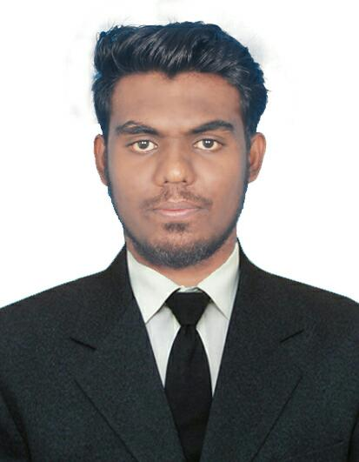
Nowsath

Email ID : nowsath.382258@2freemail.com
CAREER OBJECTIVE

Seeking a challenging position in the field of Accounts & Finance related so as to utilize my skills for organizational growth.
EDUCATION QUALIFICATION
- B. Com from University of Madras in year (2014-2017) with 73%
- Higher Secondary Course from IGMHS in year with 75%
- Diploma in computer application
CERTIFICATION

- Tally ERP 9
- Microsoft Office (Excel & word)
- Type writing
- Driving - Having Indian Driving License
EXPERIENCES
- Worked as Accountant - cum - Data Entry Operator for 1 year in Myoung Shin India Automotive Pvt Ltd, Chennai.
PERSONAL DETAILS
Date of birth : 24-04-1996
Age : 22
Gender : Male
Marital Status : Single
Language Known : English (read-write-speak)
Arabic (read-write)
Tamil (read-write-speak)

