Curriculum Vitae
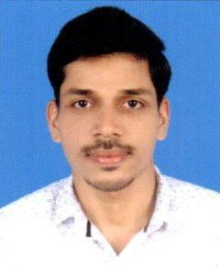

AJMAL

E-mail: ajmal.382261@2freemail.com

__________________________________________________

Career Objective

Master's Degree with Extensive experience in IT Platform, which includes System/Network administration, which will both utilize and strengthen my skills. I am looking ahead to work in challenging environment and strive for excellence in IT Support.

Profile in brief

- OS installation- Win XP, Win Server 2007, 8 and 10

- Expertise in Assembling and disassembling the computer

- Basic Networking, Data Sharing, Internet Maintenance, troubleshooting

- Sharing folder, sharing device, Printer installation and troubleshooting

- Solid Working Experience in Web Designing

- Effective presenter, trainer and team player with strong, planning, analysis and implementation skills

Working Experience

Sep 2015 – Jan 2017.

Company

: Code&Hue, Cochin, Kerala, India

Designation

: Web Developer

Key Responsibilities

:

• Team Leader of the various projects in different domain.

• Forming skill set for mobile website development using latest web technologies like HTML5, CSS3 & jQuery, Bootstrap, JavaScript frameworks.

• Implementation and maintenance of websites.

Feb 2014 – Sep 2015

Company

: Aitrich Technologies, Kerala, India

Designation

: Trainer and Web Developer

Academic Qualification

- Master of Computer Application (MCA) By Bharathiar University (Completed)

- Bachelor of Computer Application (BCA) By Bharathiar University (Completed)

Skill Profile

Operating System | : | Windows 8/10, Ubuntu
Programming Languages | : | VB, C#
Web Technologies | : | HTML5, CSS3, ASP.Net, Ajax, Jquery, Sass
Frameworks | : | Bootstrap, Foundation, EmberJS
Scripting languages | : | JavaScript
Development Tools | : | Brackets.io, Sublime, Dreamweaver CS6,
 |  | Netbeans,Construct2
Web server | : | IIS
Functional Domain | : | Internet & Web Technologies.

Personal Details

Date of Birth | : | 29th July 1992
Sex | : | Male
Nationality | : | Indian
Languages Known | : | English, Malayalam, Hindi
Marital Status | : | Single
Hobbies | : | Web surfing, Reading etc.
Visa Status | : | Visit Visa

