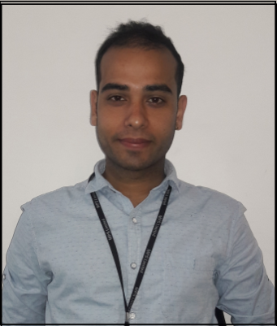
Curriculum vitae

Anurag

Email ID: anurag.382269@2freemail.com

Objective: Seeking a challenging career in Human Resource with a progressive organization which will utilize my skills, abilities and education in management whilst contributing to the development of the organization.

Educational Qualification:
- High School from CBSE Board in 2007.
- Intermediate from CBSE Board in 2009.
- Graduation (B.com) from H.N.B Garhwal University in 2012.
- Pursing MBA from SMU.

Computer Knowledge:
- Good knowledge of MS office.
- 3 months computer course certificate.

Skill & Strength:
- Positive Attitude & Hard Working.
- Self Confidence & Friendly Behavior.
- Team Work Efficiency.
- Innovative.

Work Experience:

- Currently working in M.P.S Limited as a Senior Executive - HR from 11-April-2015 till date.
(Job profile as a Senior Executive - HR in MPS PVT LTD)

- Recruitment and On boarding

- Screening resumes.
- Conducting initial interviews.
- Coordinating interviews with the hiring managers.
- Initial test conduct.
- Generate offer letter, completing joining formalities and documentation, ID creation in HRMS system also provide the HRMS Rights.
- Maintaining employee’s personal files and records, communicating HR policies, HR Induction.
- Preparing mail IDs.
- Provide punching access to the new joiners.
- Preparing various letters like appointment letter, confirmation
Letter, increment letter, transfer letter, Absenteeism notice, warning letter, experience/service certificate, reliving letter, etc.
- Send FFS Mail to Resigned employees.
- Celebrations - Diwali, Holi, and other company events.
- Effectively managing employee get together, picnic, parties, Fun Activates, Annual function.
- Developing employee engagement programs like Initiated and administered a welcome-mail policy to all new joiners, Initiated regular Birthday mailers

Pay Roll:-

- Preparing Final settlements leave salary and all employee benefits.
- Compilation attendance data from attendance system.
- Preparing Over Time Reports.
- Preparing night Shift allowance Reports.
- Also attend ISO certification audit two times.

Learning and Development and Training Session

- Conduct training session of new joiner.
- Soft skill Sessions for New joiner.
- Quarterly Orientation program.
- Interpersonal skills Sessions.

Compliance

- Download ESIC Challans, Download ESIC form for Employee.
- Done all Provident fund formalities.
- Maintained attendance register.

Personal Details:

- Date of Birth : 24- September-1991
- Nationality : Indian
- Gender : Male
- Marital Status : Unmarried
- Language Known : Hindi & English
- Hobbies : Reading books , surfing internet, listening

Music, Travelling,

Declaration:
- Here I declare that the information stated above is true & complete to the best of my knowledge.

