Key Skills

Logistics Operations

Transportation Network Management

Distribution Channel Material Management Data Entry Operations
Procurement

Supply Chain Management

Liaison & Coordination Shipment Clearance

Timeline

Bijouxtec

Dmcc

Aug’09-Jan’11

NITIN RAMESHBHAI RATHOD
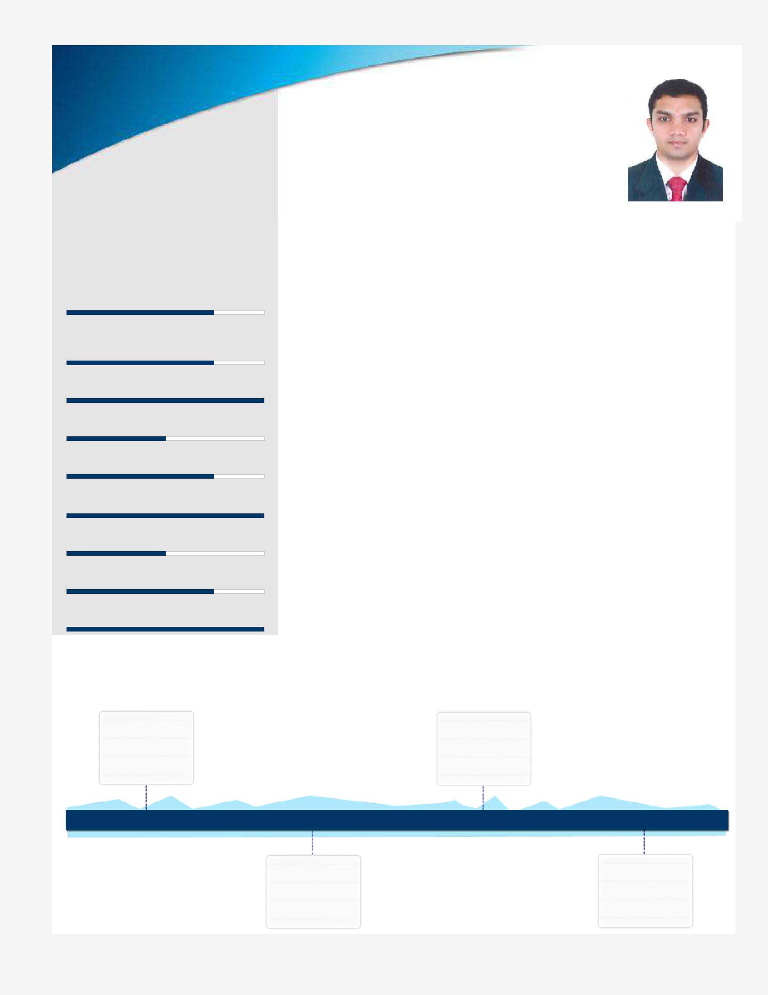

Logistics Operations

nnr2911@gmail.com055-1700436

Goal-oriented professional offering 7 years of experience in end-to-end Logistics Operations expertise that directly results in efficiency improvements & cost savings
Location Preference: Dubai
Profile Summary

- Expertise in evaluating & reviewing the company’s logistics operations business practices, updating and developing process documentation, streamlining opportunities, and eliminating non-value added activities

- Proficient in driving the development and cultivation of positive business relationships with the company’s logistics customers & vendors and directing the pricing and performance reviews to identify service and revenue improvement opportunities and managing costs

- An expert in facilitating activities that improve coordination and communication within the logistics department and other departments for shipment clearance

- Working knowledge of CFR, CPT, FCA, FOB, Mirsal - II, Custom Tariff, Letter of Credit, Bill of Lading, Dubai Customs Inspection Compliance, Nomination Haulier which enables fast and easy retrieval of containers from ports and easy cross docking

- A keen communicator with honed interpersonal, problem solving and analytical capabilities

Middle East

Plastic

Marketing

FZE

Feb’11-Dec’11 Jan’15-Aug’15 Since Sep’15

Element | Al-Khayyat
Middle East | Investment
LLC | LLC

Work Experience

Since Sep’15 with Al-Khayyat Investment LLC, Dubai, Clearing & Forwarding Executive

Key Result Areas:

- Preparing and establishing schedules based on the needs and actual requirement of procurement division
- Administering and tracking all shipment details to maximize orders

- Planning container loads with regards to customer and procurement requirement for shipping and respective customer clearance

- Coordinating with Procurement Team and updating information related to changes in delay in freight, shortages as and when required

- Managing cargo, truck, freight bookings as required and as per the specified formats and systems of key accounts and oracle system effectively

- Liaising with key account logistics / supply chain representatives to ensure timely dispatch of material, containers and vehicle booking arrangements

- Ensuring negotiation with local freight forwarders for overseas shipments & updating the sailing schedule to Procurement Team

Highlights:
- Reduced notable amount of inventory holding cost by 45 % through proper forecasting
- Attained remarkable sales growth of some stores by 25% through proper logistics planning, operation & follow-up

- Developed, documented, and executed comprehensive logistics and distribution strategic plan that drove optimal customer service and revenue enhancement by 35%

- Built the global logistics organization, US$ 1 Million in international logistics and transportation; led operational and process improvement initiatives across the supply chain logistics function with a team of 02direct and over 01 indirect reports – now am the only person handling all the shipments falling in my category of fashion / Retail

Jan’15-Aug’15 with Middle East Plastic Marketing FZE, Dubai, UAE – Logistics Coordinator

Key Result Areas:

- Managed Performa Invoices against order enquiry from customer
- Worked on database entries of more than 1000K USD

- Coordinated with local freight forwarder to release delivery order and arrange to collect original bill of lading for final customers

Feb’11-Dec’14 with Element Middle East LLC., Dubai , UAE – Logistics Coordinator Key Result Areas:

- Analyzed new customer orders & requested manually by entering data into a centralized database

- Coordinated with warehouse for all GCC export shipments / deliveries accurately which lead to 100% accuracy and fast movement of shipment
- Created customs purpose documents with local Chamber of Commerce
- Forwarded client-related quality and service issues to the appropriate manager for resolution

- Administered the costing procedure with regular checks to make sure that the costing for shipments from all international suppliers are completed timely by imports on completion of receipt of cargo into warehouse, helps sales team to push available items with Promotion and discount to achieve 100% sales target

- Developed Letter of Credit Clerk and managed the same to verify terms of credit such as amount, insurance coverage and shipping conditions to determine compliance with established standards

Highlights:

- Successfully prepared monthly export monthly sales reports lead to monitor & increase in sales from 15% to 20%

- Merit of accounting all Import & Direct Shipment Export to GCC using Weighted Average Method resulting control over cost of 2000+ sku's

- Played a pivotal role in administering and highlighting on regular interval over cost items to Procurement Department which resulted in cost cutting from 25 % to 35 %

- Liaised returns between origin and interim Transportation Departments resulting 100% customer satisfaction and resulting in 50% increase in accurate receivable accounts reconciliation

Previous Experience

Aug’09-Jan’11 with Bijouxtec Dmcc, Dubai , UAE – Junior Logistics Coordinator

IT Skills

- Sage Accounting Software
- Microsoft Excel, Word.
- Tally 9.0

Education

- B.Com. from Mumbai University, Mumbai in 2003

Certifications

- Successfully completed certifications as Logistics Supply Chain Professional with the knowledge of International Trade, Incoterms, Letter of Credit from Zabeel Institute of Management

Personal Details

Date of Birth: 30th Jul’82
Address:Al Fahidi Street, Bur-Dubai, Dubai, UAE.11245.
Languages Known:English, Hindi and Gujrathi and Marathi

