CURRICULUM VITAE

PERSONAL DETAILS
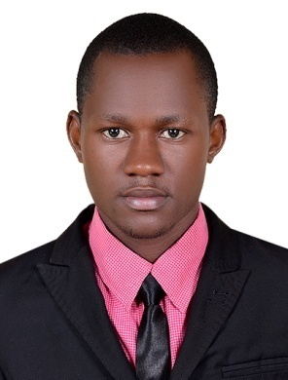
Name: KENETH.
Date of birth: 29/December/1989.
Nationality: Uganda.
Sex: Male.
Marital status: single.
Religion:. Christian.
Email address keneth.382273@2freemail.com
Visa status: employment Visa.

CAREER OBJECTIVES:
Position of WAITER & HOSPITALITY.,am afast learner individual in terms of skills and professionalism.i consider myself awell organised person who works with high level of commitment, energetic approach, flexibility on work demands and responsibility on top of my priorities.

KEY QUALIFICATIONS:
- Excellent in team work and attentive to all clients.
- Self motivated, friendly and polite in terms of communication.
- confident to handle all types of customers.
- Preparing beverages, taking and following verbal and written instructions.
- Hard working,loyal, honest, well groomed, tidy,clean and hygienic.
- Willing to work for extra hours depending to the condition and always flexible.
- High quality customer care service with strong desires.

Work experience:
2years working experience in Dubai UAE .
2years working experience as waiter in Uganda.

EDUCATION ACHIEVEMENTS:
- Ordinary level certificate 2008.
- Advanced level certificate 2010.
- First aid and safety certificate UAE 2017.
- Operating computer

REFEREES
To be provided upon request

