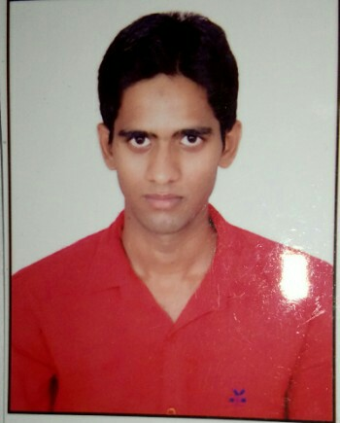

ARMAN
MIS Executive with India Experience
Nationality: India
Location: New Delhi
Email: arman.382281@2freemail.com

Objective
A Challenging position in a professional organization, where I can enhance my skills and strengths in conjunction with the Organization goal and objectives.

Educational Qualification

12th Passed from CBSE Delhi.
- Perusing BA Final Year from Delhi University.

Professional Experience-

- VIDEOCON D2H: MIS Executive from Aug’2017
- MOGLI LABS (INDIA) PVT LTD : MIS Executive 10 Months experience.
- WIPRO BPO: Transport helpdeak executive cum Transport Management 1 Years 8 Months experience.

SUMMARY OF SKILLS AND EXPERIENCE:-

Looking MIS executive ( Videocon D2H Limited).

- Working on MS Excel in operation team.
- Creating Daily Online Recharge Report.
- Payment Reversal Working on Daily basis.
- Closed Customer Complaint Related to Balance Mismatch & Billing Related.
- Vlookup, Hlookup, Pivot, Sum, Count, If, Index, Match and Etc.

Looking MIS executive ( Mogli Labs India Pvt Ltd).

- Working on MS Excel in operation team.
- Creating Payment Sheet for outstanding & overdue.
- Vlookup, Hlookup, Pivot, Sum, Count, If, Index, and Etc.

Looking transport management with MOVEIN SYNC(Employee Transport Automation Tool).

Vendor Management-Vendor supervisors & drivers on daily basis to run the operation as per guidelines of Company.

Roster preparation/Pick n drop arrangement.-Prepare & maintain the Pickup/Drop roster on daily basis.

Routing.-Holds the responsibility of preparing routes as per the company policy. Taking care of all the routes by covering all the pick-up/drop point for smooth operation.
Tracking-Keep the track of all the cabs with the help of tracking team initiated for pickup/drop of associates. Maintains the tracking in terms of providing full support to each associates so that everyone should reach office/home on time.
Compliance-Proper checking of all the cabs in terms of safety purpose i.e. fire extinguisher, first aid and relevant documents.
Making All Transport Report on Daily basis-Preparing the following OTA & OTD reports No show report, Compliance Report and sharing ahead with business partners.
Client visit Booking-Holds the responsibility of cab scheduling for pickup/drop to clients from hotel/Airport and also provide the service in case of client wishes for sight scene anywhere in India.

Personal Details
Date of Birth : 15-07-1994

