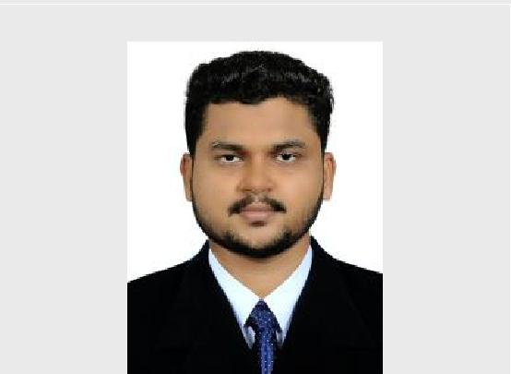
MUHSIN

Audit and Accounts
Muhsin.382283@2freemail.com

Objective

Current Location Dubai, UAE

Personal Details
Date of Birth | : 12-10-1991
Sex | : Male
Maritel Status | : Single
Nationality | : Indian

Language Known
- English

- Hindi
- Malayalam
- Thamil

Passport Dtails
Date of Issu | : 20-05-2014
Date of Expir | : 19-05-2024

Visa Details

Visa status : Visiting Visa

With an excellent professional record in Accounting and Auditing Section in India, working for a responsible position in a respectable firm, where I can escalate my knowledge and professional skills to effectively manage organizational needs in Accounting and Auditing Department.

Work experience and Training

General Accountant 2017-2018
At Alhind Tours and Travels Pvt.ltd, India.

- General Ledger Management- Month/year end closing.

- Preparation of MIS reports.

- Book keeping and Taxation.

- Handled Accounts Payable and Receivable departments.

- Liaising with auditors to ensure annual monitoring is carried out.

- Bank reconciliation and Petty cash handling.

Article Assistant 2014-2016
At Joy Thomas Charterd Accountant ,India

- Have experience in using accounting software’s extensively for accounting tasks.

- Internal audits and visited various branches of companies for audit.

- VAT,Income Tax

Article Assistant 2013-2014
At P.R Narayanan Nair & Co,India.

- Audit and Finalization of Financial Statements.

- Outsourced for Finance and Accounts section of various companies

- Handled coordination between clients and the audit team for efficient audit.

- Filing return of Income & Tax Audit Reports for Individuals, NGO and Corporates.

Education

CA Articleship 2013-2016

Joy Thomas Chartered Accountant 2014-2016
P.R Narayanan Nair and Co 2013-2014

B.Com Finance 2009-2012
Calicut University,India

Plus Two Commerce 2007-2009
Kerala Govt, Kerala

Duties and Responsibilities

- Book Keeping
- Bank Reconcilation
- Voucher Entry
- VAT Calculation

- Vouching and Verification of all accounts
- Bank Auditing
- Interbranch Reconcilation
- Finalization of Accounts
- Assistant Auditor

- Administration and over all control of a branch
- Preparation of Cash flow statement

Computer and Software

- MS Office Packages (Excel,Word,Power Point etc..)
- Tally ERP.
- Winman,E-Traveller.

Personality and Strength

- Ability to work in a Fast –Paced Environment.

- An effective communicator with good analytical ,Negotiatiation & Coordianation Skills.

- Self –Motviated and Ability to take initiative.

Declaration

I hereby declare that above furnished details are true to the best of my knowledge.

