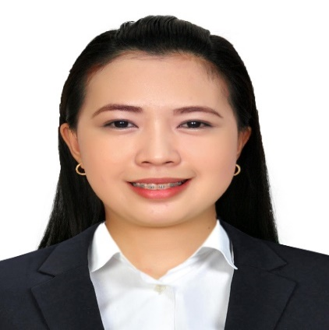
SUSARAH G. GERONDIO
Dubai, UAE
Sarahgerondio@yahoo.com
0567870473

OBJECTIVES:
- To contribute to the growth and progress of your company that values your vision and mission while developing my own skills and talents.
- To become an excellentand effective participant in the delivery of quality service to guests/customers in your company.

WORKING EXPERIENCE:

- ASTER PHARMACY
- Health Advisor/Sales Promoter
- June 18, 2017 – PRESENT
- Aster Alfa Pharmacy Al Qusais
Responsibilities :
- Welcome and greet the customers or clients as they enter the pharmacy.
- Providing exceptional customer service, a friendly customer service that helped retain customers despite fierce competition in the industry.
- Getting prescription from the patients and give them a token number.
- Answer calls professionally to provide information about products and services.
- Helping customer for their needs, or problems about in their health, do suggestive selling to increase the sales.
- Inform customer of deals and promotions.
- Billing the non-pharma items.
- Billing home delivery products.
- Removing near expiry items from gondola, 6 months from the expiry date and three months from the expiry date will send back to warehouse.
- Checking new deliver products, and put in the shelves.
- And thanking customers for their continuous patronage.

- MERCURY DRUG CORP.
  - Pharmacy Assistant
  - July 8, 2013 to October 31, 2016
  - 223 Pasay Taft Gil Puyat
Responsibilities:
- Received written prescription or refill request to verify that information is complete and accurate.
- Serves customer fast, accurate, convenient, informative and personalized service following the Dispensing Guidelines, service & selling standards.
- Maintained proper storage and security conditions for drugs.
- Provide excellent customer service. By helping the customer or patient for their needs or problem about in their health
- Answers telephone calls, providing general information, and routing other calls to appropriate party.
- Takes inventory of medicine on hand and records results.
- Maintains pharmacy inventory by checking pharmaceutical stock to determine inventory level. As well as removing the near expiry items.
- Maintains a safe and clean pharmacy by complying with procedures, rules, and regulations. Achieving individual monthly quota.
And thanking customers for their continuous patronage.

- SANFORD MARKETING CORPORATION
- Cashier
- September 3, 2012 to January 30, 2013
- D&E bldg. Plaza Naning,Poblacion,Baliuag,Bulacan
Responsibilities:
- Welcome and greet the customers as they enter the supermarket.
- Greet the customer with a smile.
- Scan all customers purchases, and put in plastic bag.
- Give total, receipt and give exact change.
- And thanking customers for their continuous patronage.

- MCDONALDS
  - Cashier/Service Crew
  - May 17, 2010 to November 10, 2010
  - Plaza Naning, Poblacion,Baliuag, Bulacan
Responsibilities:
- Welcome and greet the customers as they enter the restaurant.
- Greet the customer with a smile.
- Getting customers order, do suggestive selling to increase the sales.
- Arrange customers order, givereceiptand exact change.
- Cooking French fries
- Maintain cleanliness in the selling area.
- And thanking customers for their continuous patronage.

ON-THE-JOB TRAINING:
- OCEANLINK INSTITUTE
  - Actual Shipboard Training Onboard M/V Superferry 20
  - 12th day of February 2012 to 20th day of February 2012
  - Ermita, Manila, Philippines
- GALILEE MANSION AND GARDEN RESORT
- The Hidden Paradise
- 19th day of November 2011 to 31st of December 2011
- Gen. Alejo Santos Hi-way San Pedro Bustos Bulacan
PERSONAL PROFILE:

Date of birth :
Place of birth :
Civil Status :
Age :
Gender :
Religion :
Weight :
Height :
Citizenship :
December 10. 1991
Candaba, Pampanga
Single
26 yrs. old
Female
Catholic
45 kilos
5’3”
Filipino
EDUCATIONAL ATTAINMENT:
COLLEGE : S.T.I (System and Technology Institute)
Baliuag, Bulacan
Course : 4 yrs BSHRM
Bachelor of Science in
Hotel and Restaurant Management
2008-2012
TESDA : Technical Education and skills Development
Authority (TESDA)
Finishing Course for Call Center Agent NC II
100 hours
STRENGHTS/SKILLS:

- Good Communication Skills
- Computer Literate
- Very good Customer Service
- Multitasking
- Flexible
- Fast learner
- Hard Working
- Trustworthy

SEMINAR ATTENDED:
- CONTINUING EDUCATION FOR PHARMACY ASSIST. II
Building the trust excellent customer service # 42
Held at EJQ Building Mandaluyong City
1st of July 2014
- TRAINING FOR DIABETES
Held at Aster PHQ Bur Dubai
7th of December 2017
- TRAINING FOR UTI & CANDIDIASIS
Held at Aster PHQ Bur Dubai
12th of September 2017
- HOSPITALITY AND TOURISM CONFERENCE
Entitled “Modernized Global Trends for Better Opportunities”
Help at Stotsenberg HotelClarkfield Pampanga
24th day of August 2010

CHARACTER REFFERENCES:

- Ms. Mary Ann Capa
Assist. Unit Incharge at Aster Alfa Pharmacy
Al Qusais Dubai
Mobile#: 0558334798

- Ms. Lorna Pakaliwangan
Manager of Mercury Drug
Pasay BlueBay Walk Philippines
Mobile#: 09178632156

- Mr. LitoMangampo
Accountant at Unikai Foods PJSC
Al Quoz Dubai Arab Emirates
Mobile#: 0501265080

I hereby certify that the above information’s are true and correct to the best of my knowledge and belief.

SUSARAH G. GERONDIO
Applicant’s Signature

