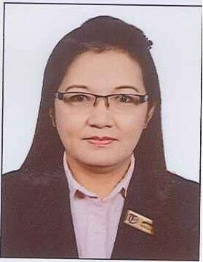
Rebecca

Email Id Visa status

: Rebecca.382293@2freemail.com

: Working Visa

Objective:

To associate with a company that will offer a better career development, a parallel professional growth. A challenging environment and opportunity for personal advancement through financial and job security

Educational Background:

College

Secondary

Computer Literate

: Davao Oriental State College of Science and Technology Midwifery

: Mati National Comprehensive High School

: Internet Surfing

Professional Skills:

- Excellent in team building, leading and mentoring teams

- Ability to learn quickly and adapt to changing environment

Work Experience:

Position | : | Store incharge
Company | : | Taif al Emirate Perfume (2012 – To date)
Address | : | Dubai UAE

Duties and responsibilities:
- Checking the items daily

- Follow up the order of the store Check the daily sale reports

Position | : | Call Center Agent (March 2011 – August 2011)
Company | : | Pizza Hut
Address | : | Sharjah, UAE

Duties and responsibilities:
- Receiving calls and take orders from the customers

- Forwarding all calls from the customers to the stores

- Responsible in answering some complain from the customers

Position | : | Sales Lady Garments for lady (1998-1999)
Company | : | Victoria Plaza
Address | : | Davao City Philippines:

Duties and responsibilities:
- Check the quality of the materials

- Check the quantity of the finish products

- Assist all the customers with pleasures

- Show all the samples so have the choice

Position | : | Promo Girl Cosmetics (1996-1998)
Company | : | Rustans Marketing
Address | : | Manila, Philippines

Duties and responsibilities:
- Monitor products in the area

- Promote and give samples of the products, show encouragement

- Assist the customers; explain why they have to buy the product

- Responsible in the monthly report

Position | : | Assistant Teacher (Sep 2011 – April 2012)
Company | : | Little Jewels English Nursery
Address | : | Cainta Rizal, Philippines

Duties and responsibilities:
- Assist teacher in all daily activities of the children

- Help the teacher maintained the cleanliness and orderliness of classroom

- Caring and supervising the children to their physical needs

- Responsible and ensure that the health and safety of the children is maintained all the times

Position | : | Cashier (March 2000 – March 2011)
Company | : | Kuwait Food Americana
Address | : | P.O.Box 6844
 |  | Sharjah UAE

Duties and responsibilities:
- Receive and collect fees

- Balance / record the day collection in the cash book

- Prepare the remittance for the bank pick up the following day

- Prepare the monthly reports on summary of collections, summary of remittance

PERSONAL DATA
Birth place | : |  | Mati, Davao oriental, Philippines
Height | : |  | 5’1
Weight | : |  | 54 Kg
Health | : |  | Excellent

