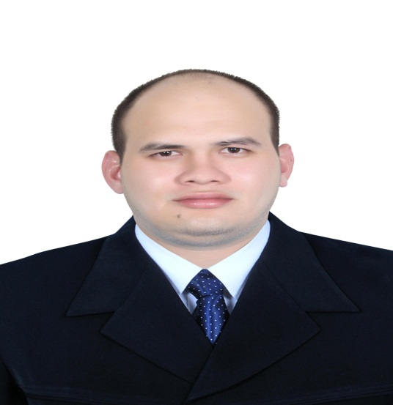

[David.382318@2freemail.com](mailto:David.382318@2freemail.com)

**CONTACTS**

Seeking a responsible and challenging position with a turbulent and dynamic organization which offers opportunities for personal and professional development and where I can best utilize my knowledge and skills.

Ability to work under pressure

Skilled in Microsoft Office

Ability to work as a team

Communication

Self-Motivation

* Supervise and motivate concession team members to achieve sales revenue.
* Hire and train concessions employees in their assigned job responsibilities.
* Organize concession events and ensure that each concession station is stocked and staffed.
* Assist in inventory management and control activities.

Concession

Supervisor

JUNE 2011 – DEC 2012

PARADISA PHILS INC. – TAGUIG CITY, PHILIPPINES

Store SupervisoR/ Merchandiser

NOV 2014 – NOV 2017

PETROMIN CORP.(PRIMO CAFÉ) - JEDDAH KSA

* Manage retail staff, including cashiers and people working on the floor.
* Meet financial objectives of the company; scheduling expenditures; analyzing variances; initiating corrective actions.
* Ensure pricing is correct, making sure that the products are clean and ready to be displayed on the shop floor.
* Coach, counsel, recruit, train, and discipline employees. Evaluating each staff job’s performance.

Customer Service Representative

JAN 2013 – SEPT 2014

TELEPERFORMANCE PHILS. – MAKATI CITY, PHILIPPINES

* Receive inbound calls including transferred sales leads and calls from current and potential customers.
* Place outbound follow-up calls to sales leads and persuade potential customers to complete and submit an application.
* Answer questions about the product details, the company, and issues with account for the customer.
* Perform basic account maintenance activities.
* Meet Quality Assurance Requirements and other key performance metrics.

**EXPERIENCE**

ZAMBOANGA CITY, PHILIPPINES

LABUAN NAT’L HIGH SCHOOL

2001 - 2004

HIGH SCHOOL

PASAY CITY, PHILIPPINES

METRO BUSINESS COLLEGE

2008 - 2010

ASSOCIATE IN COMPUTER TECHNOLOGY

**EDUCATION**

**DAVID**

**SKILLS**

**CAREER OBJECTIVE**

Adaptability

Leadership