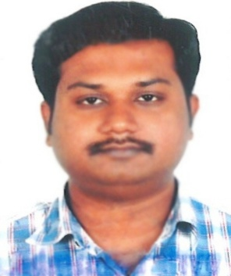
CURRICULUM VITAE
YUSUF
DUBAI U A E
Email: yousuf.382322@2freemail.com

Po

OBJECTIVE
Seeking a challenging position in a Reputable Organization offering growth potential and Responsibilities in a growth oriented concern, where I can utilize my skills and personal capabilities and grow up with organization.

WORKING EXPERIENCE
- 2 Years worked experience as a Transport Supervisor in AL- KHODARI SONS@ CO. in SAUDI ARABIA.(2014 to 2016)
- 2 Years worked experience as a Tele Marketing Executive in INDIA PROPERTY in Consume Info Pvt Ltd.
- 1 Years worked experience as a Telemarketing Executive in SERCO BPO Pvt Ltd in India

Duties and Responsibilities:-
- Advises present or prospective customers by answering incoming calls on a rotating basis; operating telephone equipment, automatic dialing systems, and other telecommunications technologies.
- Influences customers to buy or retain product or service by following a prepared script to give product reference information.
- Documents transactions by completing forms and record logs.
- Maintains database by entering, verifying, and backing up data.
- Keeps equipment operational by following manufacturer's instructions and established procedures; notifying team leader of needed repairs.
- Maintains operations by following policies and procedures; reporting needed changes.
- Maintains quality service by following organization standards.
- Maintains technical knowledge by attending educational workshops; reviewing publications.
- Contributes to team effort by accomplishing related results as needed.
AREAS OF EXPERTICE

- Am Quick And Flexible
- Having a friendly and professional manner
- Calm, Efficient and Organized
- Friendly disposition with clear spoken English
- Excellent personal Presentation and Interpersonal Skills
- Passion for exceptional customer service
- Profound ability to ensure that the highest standards of hospitality are established

EDUCATION QUALIFICATION

- S.S.L.C (Ram School Chennai )
- DIPLOMA MECHANIC(A/C - Govt Polytechnic Nagarcoil)
COMPUTER PROFICIENCY

- Knowledge of MS. Office
- Multi Media
- Photo Shop
- Web Designing

.
LANGUAGE KNOWN

- English
- Hindi
- Arabic
- Tamil

PERSONAL DATA
Gender : Male
Date of Birth : 25/05/1986
Citizenship : Indian
Status : Single

PASSPORT DETAIL
Date of Expiry : 06/09/2027
Visa Status : Employment

Yours Faithfully

YUSUF

