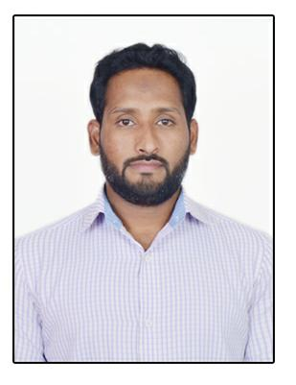
ATHIF
Sale Supervisor/Executive

Residential address: Sharjah (visit visa)
Email: atif.382354@2freemail.com

Career Objective:-

Seeking a dynamic and challenging position in the field of sales to share my post professional qualification, where I can apply my knowledge and contribute to mutual growth.

Summary:-

I have more than 9 years’ experience in sales and marketing Riyadh and out of Riyadh areas I knew Riyadh WHOLESALE MARKETS, RETAIL MARKETS, and ROAD AND STREET ALL. I have good experience in QASSIM, UNAIZAH, MAJMA, MUZAMIYA, AL KHARJ, HAIL, TABUK ARAR SAKAKA KAFJI, Etc.

Professional Work Experience:-

- Worked as VAN SALES MAN in AL AWAL factory in al hasa, Saudi Arabia from September 2007 to August 2008. Manufacturing comforters and bed line products. Selling in Riyadh and al kharj areas.

- Worked as a Sales Executive in KHALID S ENAZY TRADING EST in Riyadh from November 2008 to November 2012. Selling turkey chocolate, nuts, and snacks. Wholesale markets and retail shops. In Riyadh.

- Worked as a Sales Executive in GULF SPARROWS TRADING EST in Riyadh from December 2012 to September 2013. Selling hardware tools and diamond blade. Wholesale markets in Riyadh and out of Riyadh. Like majmah,buraidh, unaizah, hail.etc

- Worked as a Sale Supervisor in WAJHAT BUILDING SYSTEM CO in Riyadh from September 2013 to August 2015. Selling building materials and all kind of bath room accessories. Whole sale and retail markets

- Worked as a Sale In-Charge in AL MUTHALI INTERNATIONAL TRADING CO. CO in Riyadh from September 2015 to August 2017. Selling dry food items beverage and frozen items to modern trade and wholesales market Riyadh and outside Riyadh handling market

LULU HYPER MARKET KSA / CARREFOUR HYPER MARKET KSA / ALSADHAN RIYADH / NESTO MARKET RIYADH AND SHARQ.

Education Qualification:-

- Completed “Diploma in Computer Science” D’banumaiah polytechnic. M.G road

Mysore Karnataka, India.

Personal Attributes:-

- Excellent Management and decision-making skills with ability to manage field sales operations.

- Excellent communication and presentation skills with ability to conduct professional Sales Presentations.

- Remain open to new ideas and approaches and respond to change with a positive attitude and a willingness to learn new ways to accomplish work activities and objectives.

- Investing to build a stronger future organization.

- Ability to flourish in a competitive environment with the ability to cope with setbacks and routine.

Personal Skills:-

- Leadership.

- Self-Motivated and Result Oriented.

- Punctuality, Patience & Perseverance.

- Proficiency in English language.

Personal Information:-

• | Civil Status | : Married
• | Date of Birth | : 15 March 1989
• | Nationality | : Bangalore Karnataka Indian
• | Language Known | : English, Hindi, Urdu, Kanada & Arabic

Passport & Visa Information:-

• | Date of Issue |  | : 11July 2017
• | Place of Issue |  | : RIYADH
• | Driving License |  | : Valid Saudi Arabia (KSA)
Availability:-
• | Availability |  | : Immediately

