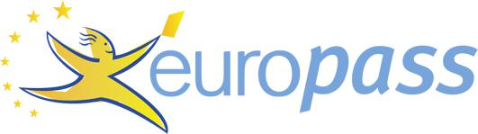
Curriculum vitae

PERSONAL INFORMATION Abiola

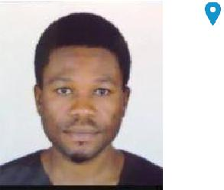

Abiola.382370@2freemail.com

Sex Male | Date of birth 27/06/1985 | Nationality Nigerian (Nigeria)

WORK EXPERIENCE

05/10/2016–22/03/2018 Assistant Systems Librarian, Cyprus International University

Manage databases subscription for journals and other e-resources in the library collection and give status update to my supervisor

Enter and update patrons' records on computers and also attend to e-library users in the use of the Dewey Decimal Classification Scheme.

Process new materials including books, audiovisual materials, and computer software and answering clientele's queries

Lend and collect books, periodicals, videotapes, and other materials at circulation desks.

Business or sector Education

05/04/2014–Present Student Representative, Cyprus International University

06/08/2015–12/08/2016

10/06/2012–26/02/2014

Collaborating and facilitating on-the-spot admission seminar with CIU International Team on bi-annual basis (i.e. Fall and Spring).

Advertising and organizing educational seminars on abroad study for Cyprus, Turkey, U.K., U.S., and Canada institutions.

Water-tight admission processing, visa guidance and counseling for applicants with flight book and airport pick-up.

Business or sector Education

Teacher, Life forte International High School Ibadan (Nigeria)

Preparation of lesson note that is Cambridge G.C.E. O level curriculum oriented Teaching subjects like I.C.T. and Business Studies.

Setting and conducting tests for proper assessment and evaluation

Developing children’s interests, abilities and coordination using a variety of creative activities including art, sport and music.

Working with parents, guardians and school administrators on students’ progress.

Organizing and supervising extracurricular activities such as Young Entrepreneurs Scheme, Public Speaking Club and Creative Writing.

Business or sector Education

Research Librarian, Wole Olanipekun & Co. Lagos (Nigeria)

Shelving and reshelving the consulted law reports &other books.

Mark for reading the 6 dailies to which the library subscribe.

 | Curriculum vitae | Abiola
 | Carrying out the exercise of certifying the true copy of exhibits for chambers court cases.
 | Managing the e-library and updating the database. | Editing and updating the
 | chambers website.
 | General organization and management of the library
 | Business or sector Legal
EDUCATION AND TRAINING
18/02/2014–16/06/2015 | M.Sc., Management Information Systems (Evaluated by Josef
 | Silny&Associates U.S.A)
 | Cyprus International University Nicosia (Cyprus)
23/09/2007–30/09/2011 | B.Sc. in Library and Information Science (Evaluated by Josef
 | Silny&Associates U.S.A)
 | University of Ibadan Ibadan (Nigeria)
16/09/2001–21/04/2015 | National Diploma, Business Administration
 | The Polytechnic Ibadan, Ibadan (Nigeria)
PERSONAL SKILLS
Mother tongue(s) | English
Communication skills | Excellent communication skill gained through public speaking in the undergraduate days as the
 | President of Literary and Debating Society for my faculty and other speaking engagements home and
 | abroad.
 | Creative writing ability gained through brief work experience in the Nigerian main stream print media
 | and freelance journalism abroad.
Job-related skills | Transformational leadership traits with which I have mentored | students whom I am in touch with
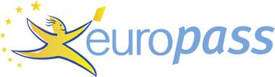

Digital skills

ADDITIONAL INFORMATION

Amiable interpersonal skill (I have had to work as reference librarian answering user queries which requires amiable personality to do)

Software knowledge and Internet savvy (both skills have help in my effective management of e-library in the traditional libraries where I have worked)

 |  | SELF-ASSESSMENT
Information |  | Content |  | Problem
 | Communication |  | Safety
processing |  | creation |  | solving

Proficient user | Proficient user | Independent user | Proficient user | Proficient user

Digital skills - Self-assessment grid

Certifications Verified Certificate in Teaching with Technology and Inquiry:

An Open Course for Teacher (K12)

University of TorontoX through Edx, Toronto (Canada)

Certificate in Teaching English as a Foreign Language

International TEFL Training Institute (ITTI)

Halitaga Cad. Kivanc Sk. 6/3, Kadikoy, Istanbul (Turkey)

General Contributions EFL Tutor (NANS Volunteer), International Students Center Lefkosia (Cyprus)

Volunteer Mentor: University of the People Mentorship Program.

The author of two thought-provoking and inspirational books: The Greatest Revolution (2009) and Beyond Religion (2011)

Publications Olarinde, A.J. (2016 ) Mobile Learning: A Sine Qua Non In Language Learning And Technology-Driven Education Process, International Journal of Management and Applied Science (IJMAS) , pp. 156-161, Volume-2,Issue-1

http://ijmas.iraj.in/paper_detail.php?

paper_id=3844&name=Mobile_Learning:_A_Sine_Qua_Non_In_Language_Learning_And_Technolo gy-Driven_Education_Process
Adeleye, I. & Olarinde, A.J. (2017) Customer Relation Management: A Business Building Tool for Small and Growing Businesses, presented at the 2nd International Conference on Business and Management, Kyrenia, 2017. American Academic Research Society (AARESOC).

https://docs.wixstatic.com/ugd/852345_bcdbadc8fbee42889bef3e64165e0def.pdf

Olarinde, A.J. (2018, April 18). Information Seeking Behavior and the Use of Electronic Resources: A Case Study of C.I.U. Postgraduate Students. Retrieved from https://afribary.com/my-works

