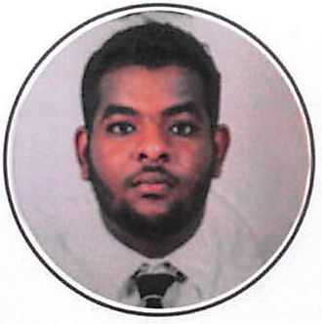

©

Ahmed

Architect

ABOUT ME

I am a dynamic and ambitious architect who possesses the desgin and development flair needed to plan, coordinate and be involved in all phases of an architectural project. On tap of all of this i have superb communica­tion skills and client liaison ability as well as a strong technical understanding of global Building Regulations.

PROFESSIONAL SKILLS

Archicad Sketch Up 3ds Max Photoshop Autocad Cinema 4d

EDUCATION

Elementry School 1997-2005

Al-Amart(l)

Khartoum,41 street, AL-Amarat .Building 32

Secondry School 2005-2008

AL-Shaikh Mustafa AL-Amin

Khartoum, 61 street, AL-Amarat .Building 7

Graduate 2008-2013

Future University

june 2013, Faculty of Architecure and Design Bacalor of Architecure (Honours (Third class by the University Senate on the june 2013

o

EXPERIENCE

Architect Designer 2013-2014

OLD TOWN COMPANY

Company for Architecural and sturcural Design Khartoum, 60 street, block 83 ,home12

Architect 2014-2016

APEX ARCHITECURAL COMOANY

Architecure company

Architecure Design , Interior Design, Strucure Design and Construted the Building.

Khartoum , AL-Nakheel street, AL-Tayf block 37 Building 2 Seconed floor

Seniour Architect 2016-2018

IN & OUT DESIGN ARCHITECURAL COPMANY

Architecure company

Architecure Design , Interior Design, Strucure Design and Construted the Building.

Khartoum. Ozone street, AL-Amarat block 12 Building 31 first floor 107

AWARDS

Best Intierer Designer

The best Intierer Design in APEX in 2016

Best Devolper Desiger

Devolop alot of Designes Spasrfec in 3ds

2016

2017

CONTACT

[Ahmed.382383@2freemail.com](mailto:Ahmed.382383@2freemail.com)