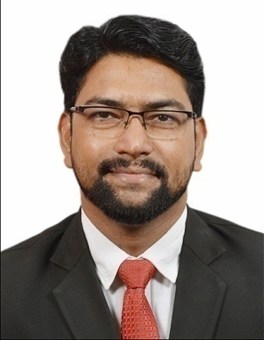
YUSUF
MID-LEVEL PROFESSIONAL
An established professional with nearly 14 years of overall experience. 10.6 years of BPO experience in training delivery, performance management and executing KPI’s/KRA’s/SLA’s while ensuring Call Calibration and Quality.
Industry Preference: BPO/Training/Customer Service/Hospitality
Location Preference: UAE
yusufshaikh79@yahoo.co.in +91-9922503120

“Merit of working as a Sr. Trainer (with ADP Pvt. Ltd.); facilitated NHT (New Hire Training), TNA (Training Need Analysis) and managed Pre-training, During and Post training needs. Along with that maintained Repository and designed SOP’s as a moderator  Personal Details  Date of Birth: 3rd May 1979  Languages Known: English, Hindi & Marathi  Email – yusuf.382394@2freemail.com | Profile Summary  - Proficient in identifying training needs (TNA) across levels through mapping of skills & competencies for different roles; customizing learning projects for achieving the set fiscal year goals of the company
- Expertise in framing work direction & plan for associates after assessment of capabilities, also setting up targets, SOP & SLA, maintaining CTQ (Critical to Quality)/CTP (Critical to Process) targets
- CSI (Customer Service Index) /NPS (Net Promoters Score) – Instrumental in monitoring the overall functioning of processes, identifying improvement areas and implementing adequate measures to maximize customer satisfaction level
- Instrumental in Designing PMS (Pay for Performance), R&R (Rewards and Recognitions), Leave Management and Associate Engagement Action Items
- Acting Team Leader – Conducted Huddles, Monitored Work Queue, Managed escalations and ad hoc tasks
- Exhibited excellence in supporting operations on CRM platform/Pay-Systems for numerous clients with competent cross-functional skills & on-time execution
- Instrumental in Screening, Interviewing and Recruitment of new hires
- Insightful exposure in delivering trainings on English Grammar, IELTS, Call Center Etiquettes and Soft skills
- Call Calibration to ensure quality by providing feedback. Instrumental on a project to reduce the AHT
- Education Sector - Counselor and Center Coordinator
- ISO Office Executive – Internal audits for ISO9001 (QMS)- Identifying Non-Conformities and taking corrective actions
- Hospitality - Front Office Executive for 2 years

Academic Details
- Pursuing PGDBM (Human Resources) from Welingkar Education, Mumbai
- B.Sc. (Computers) from Swami Ramanand Teerth Marathwada University, Nanded, Maharashtra in 2002

Career Timeline
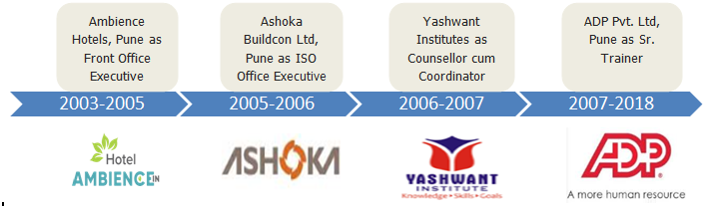
Core Competencies

Service Delivery Operations | Training & Development
Team Management | NPS/CSI (Quality Management)
Strategic Planning & Execution | Reporting & Documentation
Hiring and Recruitment  Teaching English, IELTS, Soft Skills | Business Analysis  Hotel-Front Office Management
Organizational Experience
Dec’ 2007 – May 2018 with ADP Pvt. Ltd, Pune as Sr. Trainer

Deputation/ Assignment:
Dec’ 2007 – Jan’ 2014 Process Associate, Sr. Process Associate & Quality Analyst
Feb’ 2014 – Feb’ 2017 Trainer (Senior Analyst – Training)
Feb' 2017 – May 2018 Sr. Trainer

Key Result Areas:
- Facilitating a training program for a team of over 100+ associates for various functions especially for New Joiners
- Devising 30-60-90 days PMS (Pay-for-Performance) Program in alignment of fiscal goals of the company
- Managing Pre-training, During-training and Post-training programs on regular basis based on the Training Need Analysis and designing various training modules to conduct refreshers to exceed the deliverables
- Customizing a plan in preparing & implementing the SOP (Standard Operating Procedures) for transitioning the process; facilitating smooth transition of processes from various client locations (US)
- Mapping clients, identifying improvement areas & implementing measures for ensuring and maximizing customer satisfaction levels
- Setting out quality standards for various operational areas, ensuring a high-quality customer experience while adhering to the SLAs and work processes
- Identifying TNA for better customer experience and conducting quality training programs for the stakeholders
- Working towards the liaising with the client for ensuring all committed KPIs and KRAs as part of the contractual agreement are delivered as per timelines
- Liaising & coordinating with Lien Experts, Solution Center, Disbursement Team, Compliance Team & Agency Relations

Significant Accomplishments:
- Played a key role as Moderator for ADPworks and worked on updating repository
- Ensured that process quality control framework was strictly implemented and maintained to safeguard 100% process audit – Applying quick control checks by doing RCA (Root Cause analysis)
- Implemented quality initiatives for improving team performance and increased team’s quality score from 80% (under performance) to 98% (top performance)
- Adopted effective measures and maintained a 100% retention in training and post training for 6 months
- Honored with the following awards:
- Gem of the Month – Mar’17
- Quality of the Honor – Dec’12
- Titan of the Month – Oct’12
- Idol of the Month – Mar’11
- Quality of the Honor – Feb’10
- Quality of the Honor – May’08
- Star of the Month – Mar’08
- Best Performer of the Year Trophy on the occasion of Annual Day in 2008

Previous Experience
Jan’07 -Dec’07 with Yashwant Institutes (University Centre), Pune as Counsellor and Coordinator

Dec’05 -Dec’06 with Ashoka Buildcon Ltd, Pune as ISO Office Executive (9001:2000)

Jul' 03 - Aug'05 with Ambience Hotel, Pune as Front Office Executive

Was Instrumental in Projects
- CSI (Client Service Index)/EQI (Effortless Quality Index) – Measuring and improving every touch point where clients have visibility and improving upon NPS (Net Promoters Score); improved NPS from 35% to 50%
- Passive Se Promoter Tak - Accuracy Improvement Project for escalated clients which resulted in client retention, and increased CSAT/NPS scores
- AHT: Reduced AHT of incoming calls by 25%- Enhanced IVR capabilities and knowledge retention
- Write-off Reduction: Did Pareto Analysis (80-20) on Write-off RCA’s and implemented control checks to mitigate leakage of penalty amount
- Power of 10: Identified bottom 10 low performers and improved their accuracy by 20%

Certifications
- Certified BPO Team Leader (CBTL) from QAI NASSCOM
- Certified BPO Quality Analyst (CBQA) by QAI NASSCOM
- Smartrain - A Leadership Program
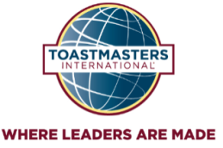
- Competent Communicator (CC) – ADP Toastmasters International
- Competent Leadership (CL) – ADP Toastmasters International

Trainings
- Pursuing “Train The Trainer” from British Connections, Pune

Trainings Imparted-
- NLP and Mind Power Coaching to set and to achieve personal and business goals
- Public Speaking, Vocal Variety, Organization of Speech and Body Language
- Critical Thinking
- Team Building
- Elements of Effective Communication
- Leadership and Team Management
- Emotional Intelligence

Extracurricular Activities
- Acted as VP - Education in ADP, Pune (Toastmasters Club)
- Established ADP TM Club and consistently playing various leadership roles
- Represented ADP Toastmasters Club at Area Level Contests (Three Times)
- Adjudged as the winner of Humorous Speech Contest (ADP Toastmasters International)
- Adjudged as the winner of International Speech Contest (ADP Toastmasters International)
- Selected as 2nd Runner-up in International Speech Contest (ADP Toastmasters International)

Soft Skills

Motivator & Collaborator

Honest & Trustworthy

Lateral & Critical Thinker
Detail Oriented
Planner & Executor

