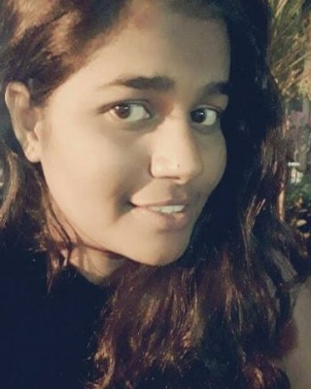
Athira
E-mail : athira.382402@2freemail.com

Summary

To seek a position in a reputed organization that could provide me with ample scope for professional growth in the field of Human Resource Management and social work.

Strengths
Good communication skills
Positive attitude
Good decision making
Strive for constant improvement
Responsible
Dedicated
Patience

Work experience

CIBA Center for Incubation and Business May 2017 — June 2017
Acceleration
Internship
Job training programme in Organizational setting under Mr. D.S Prashant.

Education

MA in Psychology (HR) June 2016 — April 2018
St. Xavier’s College, Mapusa Goa
RESEARCH
Dissertation titled ‘Personality and Occupational Self- Efficacy among women entrepreneurs’ as a part of MA Curriculum.

WORKSHOPS ATTENDED
Two-Day State level Workshop titled “Rorschach Inkblot Test: Exner’s Comprehensive System”. In St. Xavier’s College, Mapusa organized by the AbbéFaria post graduate department of psychology on February 2018. Difficult dialogues certificate workshop titled “Communication, Consent and Trust in decision making”. In Goa Medical College supported by the national health mission on February 2017.
Athira Letha 1

EXPERIENCE
Conducted aptitude tests (DBDA) for 5 students (std X) St. Britos School, Mapusa.
Trained students and completed Camp Rainbow Regional Capacity Building Workshop and day camp on
Psychosocial Interventions for children living with HIV at St. Xavier’s college, Mapusa from September 28th to 1st October in 2017.
BA in Psychology June 2013 — April 2016
Chowgule College, Margao Goa

RESEARCH
Project titled ‘Quality of Sibling Relationship among Same Sex and Opposite Sex Siblings’ as a part of Third Year Curriculum.
Higher Secondary  ARTS at Chowgule College, Margao Goa | June 2011— March 2013
S.S.C.E | June 2010 — March 2011
Presentation Convent High School, Margao Goa

Skills

Advanced knowledge in computers – completed a 6 months course in ADCA.

Interests
Teaching
Social work
Work Psychologists
Organizational behavior

References

References available upon request.

Personal Information
Date of Birth : 24th July, 1995
Gender : Female Marital Status : Single
Nationality : Indian
Languages : English, Hindi, Konkani & Malayalam
Athira 2

