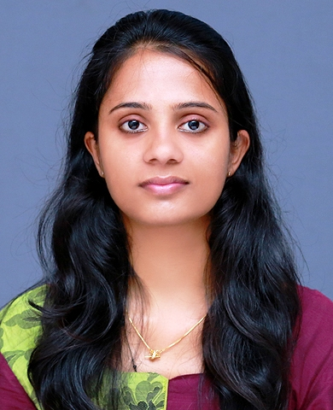

JEWEL

E-mail:jewel.382413@2freemail.com
Ajman, United Arab Emirates

HIGHLIGHTS

- Completed Master Degree in Computer Application
- Completed Bachelor in Computer Application
- Worked in Computer Science department in CBSE Schools(Faculty/Office Works)

CAREER OBJECTIVE

To be employed in a position, where I will be able to contribute substantially to the growth of an undertaking myself growing with it as well as, heartily serving the employer and customers alike. I believe that I could fit easily into your team.

EXPERIENCE

MARIAN PUBLIC SCHOOL, MARYGIRI (Affiliated by CBSE) from June 2017 to March 2018

- Teaching computer science in Higher Secondary (C/C++,SQL, Data Structures, Communication).
- Handling School Website (Back end).
- Media coordinator for events.

MARY MATHA PUBLIC SCHOOL (Affiliated by CBSE) from July 2015 to March 2017

- Teaching computer science in High School(C,C++,SQL, Data Structures, Communication).
- Handling School Website (Back end).
- Digital class coordinator.
- Media coordinator for events.
- Type, print and arrange question papers for exams.
- Check and give reply to Emails.
- Doing all CCE (Continues Comprehensive Evaluation) online works of school as per CBSE rule.
- Organizing and storing paperwork, documents and computer-based information.

EDUCATION

- Master of Computer Application (2011-2014) from Mahatma Gandhi University, Kerala, South India with first Class (69 %).

- Bachelor of Computer Application from (2008-2011) Mahatma Gandhi University Kerala, South India with first Class (64 %).

- Higher Secondary (2006-2008) from St. Philomena’s Higher Secondary School Kerala, South India with first Class (71 %)

- SSLC from St: Mary’s High School (2006) Kerala, South India with first Class (69%).

SKILLS

Operating System: Windows 7,windows 8,windows 10.
Languages: C/C++, PHP(CodeIgniter), Visual basic.

• Ability to operate basic MS office tools (Excel, Word, and Power Point)
• Good team player and ability to handle multiple tasks
• Goal oriented and ready to take initiatives
• Ability to build and maintain effective working relationships with parents and colleagues.
• Understanding of need to remain flexible to support last-minute demands and changes.

ACADAMIC PROJECT EXPERIANCE

Main project in MCA : Open Auction House in PHP (CodeIgniter)
Mini project in MCA : News Portal in JSP
Main Project in BCA : Article Management System in ASP.net
Mini project in BCA : Hotel Management System in VB

ACADAMIC SEMINAR EXPERIENCE

Seminar in MCA : Oculus Rift(Virtual Reality Head Mounted Display)
Seminar in BCA : Internet Explorer 11(Browser)

ACHIEVEMENTS
- Won First Prize for Word Hunt from Mar Athenasious College of Engineering, Kothamangalam in TAKSHAK ’13(IT Fest).
- Won Second Prize for Word Hunt from Santhigiri College ,Vazhuthala in ESPERANZA’13(IT Fest).
- Won prizes for dance competitions in district, sub district and KCSL

PERSONAL INFORMATION
Visa Status | : | Visiting Visa
Date of birth | : | 28/12/1990
Marital status | : | Single
Gender | : | Female
Nationality | : | Indian
Reference | : | Available upon request

DECLARATION

In conclusion, I would like to assure that I am capable of handling any job assigned to me, which suits my qualifications and experience with utmost care coupled with leniency and efficiency to the total satisfaction of my superiors.

