RESUME

Reji
E-mail: reji.382436@2freemail.com

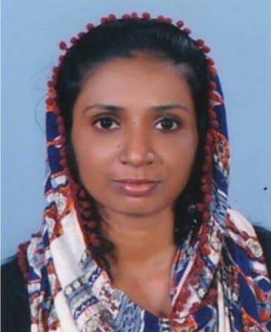

Personal Summary

An account professional with 5 years of experience, currently seeking a challenging position within a progressive organization where I can use my skills and knowledge for professional growth related with accounts and finance management, whilst working in accordance with the mission and vision of the organization.

Computer Knowledge

- Full professional proficiency for M S Office and Tally
- Internet Applications, Browsing and Emails
- Working Platforms; Windows
- Proficient in daily used computer applications

Professional Experiences

Hyundai Motors, Trivandrum, Kerala, India.
Accounts and Admin (Oct 2017 - Dec 2017)

- Post and process journal entries to ensure all business transactions are recorded.
- Bookkeeping and daily recording of financial transactions.
- Petty cash payments as per company’s policy.
- Documentation and filling of all transactions.
- Schedule meeting for sales team.
- Admin related documentation and filling of documents viz. ID proofs, banking documents of clients.

Marikkar Motors Limited, Trivandrum, Kerala, India.
Accounts cum Cashier (Apr 2014 - Mar 2017)

- Post and process journal entries to ensure all business transactions are recorded.
- Bookkeeping and daily recording of financial transactions.
- Update accounts payable and perform reconciliations.
- Prepare daily cash flow requirements.
- Petty cash payments as per company’s policy.
- Collect are required payments from clients upon purchases.

Shine Marbles, Trivandrum, Kerala, India.
Accounts Assistant (Mar 2012 –Mar 2014)

- Responsible for month and year end financial statements for company accounts.
- Carrying out cash flow forecasts, completing monthly and yearly financial statements (P&L and BS).
- Interacting with auditors to ensure time completion of audit.
- Checking of payment vouchers and receipt vouchers issued.
- Monitoring bank balances, issuing of cheques and PDC management – supervising weekly and monthly BRS (Bank Reconciliation Statement).
- Manage day to day bank transactions and day to day transaction reports.
- Control petty cash; prepare render accounts of individual and departments.
- Taking care of manual and computerized system of disbursements of salary.
- Manage the invoice generation and follow up for timely payments.
- Records/File Maintenance: Preparation and maintaining sales and purchase registered including registers of shareholders.

Academic Qualifications

Graduation : Bachelor of Commerce from Kerala University (India)

Personal Information

Date of Birth : May 14, 1989
Gender : Female
Nationality : Indian
Marital Status : Married
Language Known : English, Hindi, Tamil, Malayalam
Visa Type : Visit Visa

Declaration & Signature

I hereby affirm that the information in this document is accurate and true to the best of my knowledge.

Reji

