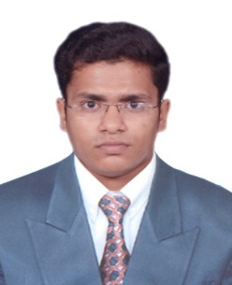
Asfar

United Arab Emirates
Asfasr.382442@2freemail.com

CAREER OBJECTIVE
To have a growth oriented and challenging career, where I can contribute my knowledge and skills to the organization and enhance my experience through continuous learning and teamwork.

WORK EXPERIENCE
July’16-June’18: TATA STEEL, Kalinga Nagar, India as MechanicalSite Engineer.
Key Result Areas:
- Assessing project requirements.
- Measuring the performance of mechanical components, devices and engines
- Testing, evaluating, modifying and re-testing products.
- Liaising with supplier.
- Writing reports and documentation.
- Oversee the selection and requisition of materials.
- Oversee quality control and health and safety matters on site.
- Manpower Arrangement and coordination.
Achievement:
- Proud to receive the best supervisor award and recognition by TATA STEEL that highlight my standing as a top team player.
EDUCATION
Degree | Branch | University/College | Year | CGPA
B Tech | Mechanical  Engineering | BPUT | 2015 | 6.9 Aggregate
Diploma | Industrial Safety | Gulf Training Institute, Mango, Jamshedpur | 2016 | 89%

TRAININGS/PROJECTS UNDERTAKEN
Name of Institute/Organization | Project Title | Duration
IDTR,Jharkhand | AutoCAD | 2 Weeks
Seemanta Engineering College , Odisha | Steam generating power plant using LPG gas | 2 Months
Foreman Training Institute, Jamshedpur | Inspection& Quality control | 2 Weeks

KEY SKILLS
- Structural engineer  - Industrial Safety  - Fire Management | - Mechanical maintenance  - Site supervision  - Quality inspection

COMPUTER SKILLS
Microsoft Office, AutoCAD, Tally (ERP Version).
PERSONAL DETAILS
Date of Birth : 28th May 1994
Marital Status : Single
Sex : Male
Nationality : Indian
Religion : Muslim
Language Proficiency : English, Hindi and Urdu
Visa Status : Visit

DECLARATION
I hereby, declare that the above stated information is true to the best of my knowledge and belief.

