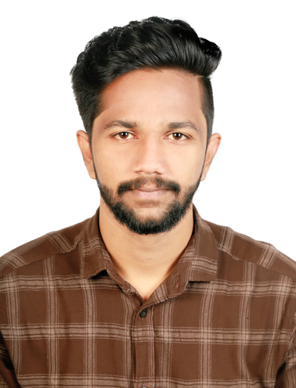
CURRICULAM VITAE

AVINASH

Email: avinash.382452@2freemail.com

OBJECTIVE
Seeking challenging assignments in a growth-oriented organization of repute in the Service Industry that can make use of my extensive skills and experience.
EXPERIENCE
- TRAINEE DESIGN MEP ENGINEER
SPACE MEP CONSULTANTS THRISSUR - DEC 2017 TO FEB 2018
- Planning, Design and Implementation of MEP Services in a
Building

- Heat Load Calculations, HVAC Layout Drawings, HVAC
Schematic Diagrams

- Designing of Electrical Single Line Diagram based on Load
study, Lux Calculation, Rating, Calculations of Switch Gears,
Earthing

- Plumbing Systems and preparation of its corresponding drawings, Material Specifications, Fixtures and Site Supervision
- BOQ Estimation and Analysis

- IOCL (INDIAN OIL COOPERATION LIMITED DIVISIONAL OFFICE) GOA–
DRAFTSMAN For 3 Months

EDUCATIONAL QUALIFICATION

QUALIFICATION | INSTITUTE | GRADUATED YEAR
Diploma in MEP Design and Drafting | Space MEP Academy | 2018
Diploma in Mechanical | Jeeva’s Polytechnic College- | 2016
Engineering | DOTE University
High School | S.N. Vidya Bhavan | 2012
(CBSE) | (Completed 10th)

IT SKILLS

- Microsoft Office (~Microsoft Word, Microsoft Excel, Microsoft PowerPoint, Microsoft Access, and Microsoft Outlook )
- Photoshop

- Internet & Emailing

- AutoCAD

PROJECTS

- Generation of electricity using the flow or velocity of exhaust gas of the engine.

STRENGTHS

- Adaptability

- Communicative skills

- Strong interpersonal skills

- Leadership quality

- Highly motivated, enthusiastic and creative individual

HOBBIES

- Travelling

- Playing Cricket, Badminton

PERSONAL DETAILS

Date of Birth:20/11/1995

Religion: Hindu

Nationality: Indian

Sex: Male

Marital status: single
Languages known: English, Malayalam, Hindi, Tamil
Driving License : Indian Driving License
PASSPORT & VISA DETAILS
Date of Issue : 04/02/2017
Date of Expiry : 03/02/2027
Place of Issue : Cochin
Visa Status: Visiting Visa

DECLARATION

I hereby declare that all the facts stated above are true and correct to the best of my knowledge and belief.

