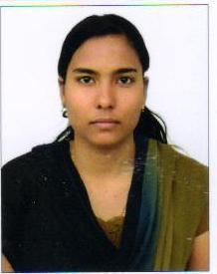
Mis.CHINCHUMOL

(Registered Nurse with DHA License)

Email-ID:

Chinchumol.382470@2freemail.com

Objective

A career in a reputable organization with challenging opportunities for growth and shouldering responsibilities in any suitable position to prepare for emerging advances with intent to serve the company.

Profile

Experience of over 6 year 6 months in ICU as a staff nurse.

Education

- Registered nursing from st. martin de pores school of nursing cherukunnu,kannur under kerala nursing council. During the year of 2007 to 2011.( 3YEAR AND 6 MONTHS)

- Secondary school ( plus two) from nirmala higher secondary school chemperi, kannur during the year of 2005 to 2007.

- S.S.L.C from deva matha high school paisakary,kannur ,year of 2005

Professional Experience

- EMPLOYMENT 1

Company : NMC Specialty Hospital Dubai, UAE

Duration :From 07/12/2014 to present.

Designation : Registered nurse in ICU

- EMPLOYMENT 2

Company: Krishna institute of ,medical science Secunderabad,
Duration | AP,India
 | :11/11/2011 to 30/11/2013
Designation | :Registered nurse in medical ICU

- EMPLOYMENT 3

Company : St.martin de porres hospital .cherukunnu,kannur,kerala

Duration : From 25/05/2011to 28/10/2011

Designation : Registered nurse in Emergency and trauma care

INTERNATIONAL CERTIFICATION
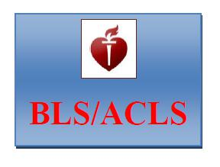

ACLS &BLS Qualified. Accredited by American Heart Association

DUTIES AND RESPONSIBILITIES :

- Assessment, planning, implementation and evaluation of the nursing care requirements of their allocated patients.

*Share professional knowledge and skills with all colleagues, Organization and management of nursing care.

*Maintain the core values of the profession.

*Efficient recording of all necessary documentation.

*Timely identification and communication of any issues to ward manager.
*Maintain an effective interdisciplinary communication process.
*Attend all mandatory education session
*Participating in all ward and hospital communication process.
*Be a preceptor to students and newly appointed staff.

Personal Information

Date of Birth
Sex
Marital Status
No.of children
Nationality
Height
Weight
Hobbies
Languages Known

: 01/06/1988
: Female
: Married
: One.
: Indian
: 164 cm
: 64kg
: Traveling, Music, Cricket, gardening, reading.
: English, Hindi, Tamil, Telugu, and Malayalam.

Strengths

- Resourceful person

- Communication and organization skill
- Willing to learn and work under pressure & having team spirit

- Responsible and knowing how to priorities my work
- Always willing to take up new challenges(multitask)

- Able to work efficiently in a team

