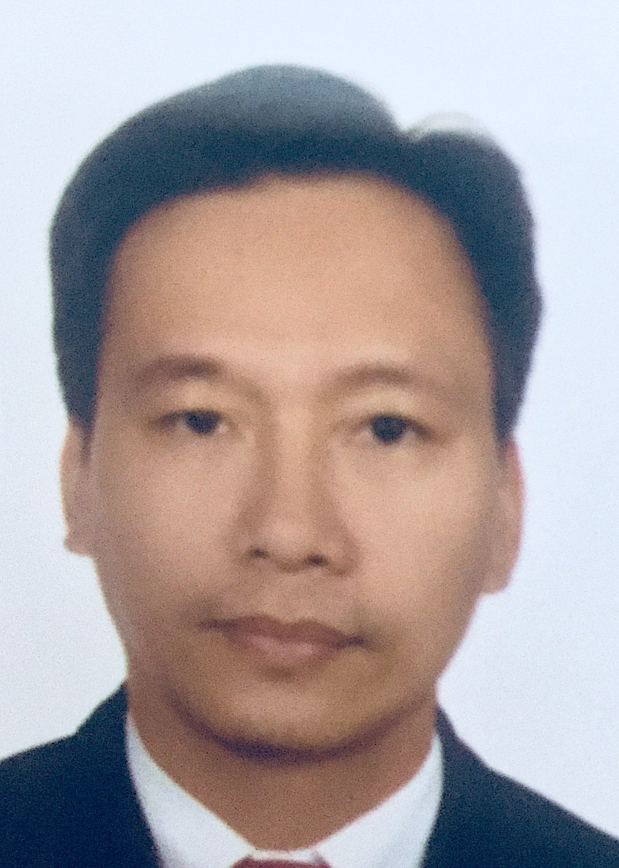
DENNIS

Email address: dennis.382471@2freemail.com

POSITION: AUTOCAD DESIGNER

EMPLOYMENT HISTORY

1. FAÇADE DESIGNER (Part-time) APRIL 2018 to Present
TWI
Al Barsha, Dubai, U.A.E.
- Responsible in making concept drawings & shop drawings.
- Responsible in making revisions as per client and contractor comments.

PROJECT INVOLVED:
1. A2A3 The Address, Dubai
2. EXPO 2020, Jebel Ali, Dubai

2.DESIGN ENGINEERSEPTEMBER 2017 to MARCH 2018
White Aluminium Enterprises LLC
Mussafah, Abu Dhabi, U.A.E.
- Responsible in making concept drawings & shop drawings.
- Responsible in making revisions as per client and contractor comments.
- Responsible in making Fabrication drawings of the approved shop drawings.
- Uses Business Integration software in encoding Material Take-off, Work Order and Glass orders.

3.AUTOCAD DESIGNER DEC. 2014 TO JUNE 12, 2017
JML FAÇADE, LLC
Rashidiyah, Umm Ramool, Dubai, U.A.E.
- Responsible in making shop drawings.
- Responsible in making Revisions of the shop drawings as per contractor and consultant comments.
- Responsible in making Fabrication drawings of the approved shop drawings.

PROJECT INVOLVED:
1.Abhu Dhabi International Airport-Extension T1,T3, Abhu Dhabi
2.King Khaled International Airport, Qatar
3.BLUEWATERS WHARF RETAIL Dubai, UAE

4. CAD DESIGNER MAY 12, 2012 TO NOV 2014
ALUMCO UAE, LLC
Dubai Investment Park, Dubai, U.A.E.

- Responsible in making Concept drawings and Shop drawings.
- Responsible in making Revisions as per Consultant/Contractor comments.
- Responsible in making Fabrication drawings for Curtain wall (Stick system and Unitized system), Doors, Windows, Skylights and Aluminum Cladding Panels.
- Responsible in making Material Take-off (Uses 1D/2D Optimization or SHUCAL) as per approved shop drawings.
- Responsible in making Glass Take-off as per approved shop drawings.
- Discuss with the Team leader for the assigned job and date of submissions.
- Discuss with the Structural engineer as per the design of Brackets/Steel truss/Curtain walls/Doors/Windows and Spider facades.
- Reports to the Technical/Design manager

PROJECTS INVOLVED:
- Project name: PRESIDENTIAL BUILDING
Location: Abu Dhabi, U.A.E.
- Project name: Meena Plaza
Location: Abu Dhabi, U.A.E.

- Project name: CREDIT LEBANAISE
Location: Lebanon
- Project name: Aziziah Project
Location: K.S.A.
- Project name: Galleria Project
Location: K.S.A

5. CAD DESIGNER/ENGINEER Nov. 23, 2009 – Dec. 10, 2011(Finish Contract)
NAFCO
2nd Industrial City, Dammam, Kingdom of Saudi Arabia

- Responsible in making Shop drawings for a new project which includes elevation, plan, section, and details.
- Responsible in making revisions as per approved shop drawings.
- Responsible in dealing with the Project manager for the approval of the shop drawings.
- Responsible in making the Cutting List of Curtain wall (Stick system), aluminum cladding, aluminum doors and windows, and aluminum louvers.
- Responsible in making material calculations as per the approved drawings.(2D OPTIMIZATION using LOGICAL 4.0)
- Responsible in going On-site visit for dimension checking.
- Responsible in checking for the material as per the Cutting list.
- Discussed with the Technical manager for the submission of shop drawings.

PROJECTS FINISH:
- Project name: AL JARBOU TOWER
Location: Al Khobar, K.S.A.
Contractor: AL MALKI
- Project name: BAKER HUGHES
Location: Al Khobar, K.S.A.
Contractor: ARNAOT CONTRACTING ESTABLISHMENT
- Project name: SAMSUNG NAFORA SAUDI ARABIA
Location: Al Jubail, K.S.A.
Contractor/Consultant: AMANA CONTRACTING
- Project name: KING SAUD UNIVERSITY FOR GIRLS
Location: Al Riyadh, K.S.A.
Contractor: BIN LADEN CONTRACTING
- Project name: Aircraft Accessories and Components Co. Ltd
Location: Jeddah, K.S.A
Contractor: Abdul Razek A. El-Ferra

TRAININGS AND SEMINARS:

AUTOCADD Autodesk 2004/2006/2008/2010: 2D& 3D Architecural Design
Autodesk 3DS MAX 2009
Adobe Photoshop CS 4
Schuco Seminar (March 2014)

GOVERNMENT EXAMS EARNED:
Civil Service – Professional Eligibility Percentage: 82%

EDUCATION:

COLLEGE :SAINT LOUIS UNIVERSITY, Baguio City
Bachelor of Science in Electronics and Communication Engineering
1994 -1999
: INTERNATIONAL CORRESPONDENCE SCHOOLS, Manila
Diploma in Computer Engineering
1997-1999

PERSONAL DETAILS:
Date of birth : March 27, 1977
Sex : Male
Status : Married
Nationality : Filipino
Visa Status : Tourist Visa
Language Spoken: English and Tagalog and Basic Arabic

TRAININGS AND SEMINARS:

AUTOCADD Autodesk 2004/2006/2008/2010: 2D& 3D Architectural Design
Autodesk 3DS MAX 2009
Adobe Photoshop CS 4
Schuco Seminar (March 2014)
GOVERNMENT EXAMS EARNED:
Civil Service – Professional Eligibility Percentage: 82%

