CLINTON
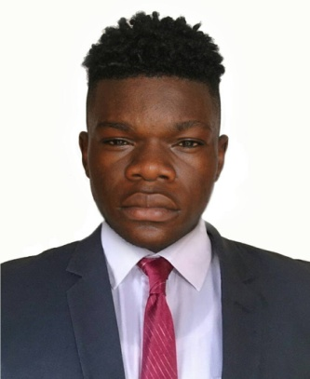
Dubai, UAE
Clinton.382480@2freemail.com

Personnel Information

Nationality: Cameroonian
Date of Birth: 21st May 1999
Marital Status: SINGLE
Language: ENGLISH (fluent)
Visa Status: Tourist visa
Position Applying: Housekeeping attendant
Objective

To obtain a challenging Housekeeping position that will greatly adhere to my desire to progress further in my career. Also to grow with an organization that has proven to be an asset for its effective functioning and well known for its highly exceeding achievements and services to their guest and employees.
Strengths & Skills

- High-level interpersonal communication (written and verbal) abilities
- Customer service orientated with a strong commitment to providing quality service
- High level awareness of workplace health and safety regulations
- Self-initiated team player
- Resourceful and adaptable to changing environments and practices

Work Experience
Housekeeping attendant May 2017 – June 2018
Marklords Hotel, Kumba, Cameroon
- Offer professional, friendly and engaging service
- Clean all assigned guestrooms including: dusting, making beds, soiled linen removal from rooms, and retrieval of clean linen from linen closets, vacuuming, bathroom cleaning, inside window cleaning, replenish rooms with supplies
- Sign in and out master keys daily
- Maintain proper usage of cleaning supplies and equipment
- Update and record all cleaned rooms
- Return and properly tag all lost and found articles in the Housekeeping Office
- Follow departmental policies and procedures and service standards
- Report necessary maintenance items
- Follow all safety and sanitation policies

Steward June 2016 - May 2017

Ngassa Restaurant, Kumba, Cameroon
- Check equipment daily to ensure they are in good working condition and promptly report any defects/malfunctions to the Stewarding Supervisor
- Cleans stoves, ovens, grills, refrigerators, and using cleaning solutions, brushes and wash cloths.
- Washes utensils, such as pots, pans, and trays by hand using cleaning detergents. Washes dishware, glasses, and cutlery by hand or machine. Occasionally polishes utensils. Drains dries and stacks items after washing.
- Transports food supplies, such as meats, vegetables, fruits, and canned foods from storeroom or freezer, using trolley/basket to kitchen. Returns surplus food to storeroom or freezer.
- Assist in transporting of food, beverage and other items to and from the kitchen.
- Dry cleaning kitchen and making sure it is clean at all times
- Washing and preparing/ making ready food items to be prepared by chief cook

Interests

- Online research and reading
- Outdoors (Camping, Hiking)
- Travelling (Experiencing different cultures, seeing the world)
- Modelling, music and movies
Education
CLABBIC Kumba , Cameroon 2014- 2016
- GCE Advanced Level Certificate , Kumba, Cameroon
CLABBIC Kumba, Cameroon 2009-2014
- GCE Ordinary Level certificate , Kumba, Cameroon
References

References can be supplied on request

