ARUN  arun.382482@2freemail.com | 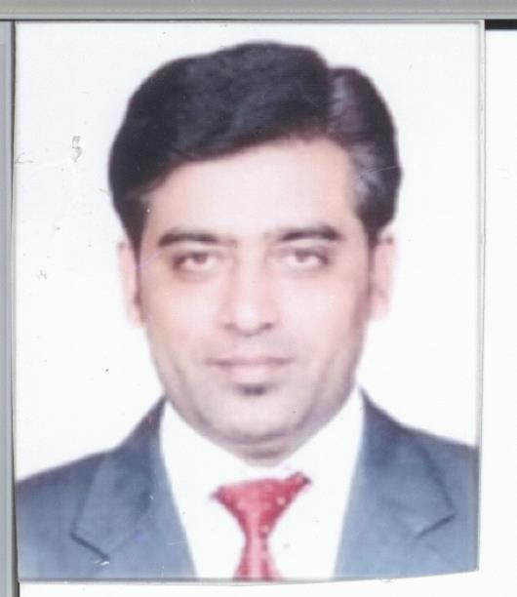

Professional Summary
A seasoned Healthcare SME with over 8 years’ of experience in healthcare domain, Healthcare Claims Data and Management. At present employed with Genpact LLC with Aetna International as the client. Responsible for maintaining QA tracker, Productivity and other activities. Maintain awareness on the various health care related regulations and trends. Also, provides support by preparing trackers which help in smooth functioning of operational excellence. Right now seeking a suitable position with a company that employs smart people and offers its staff great opportunities to learn, grow and succeed.

Skills
- Healthcare Claim SME
- MS Office Package
- MIS Reporting
- Claims Data Management
- Medical Claims Reimbursement
- HIPAA Regulations

Experience
Working with Genpact International Services Pvt. Ltd. as a Process Developer at Gurgaon from July 2011 till April 2018.
Job Profile: (AETNA INTERNATIONAL- HealthCare Insurance)

  - Post joining the process I was promoted as a Quality Auditor for provider claims and is responsible for team accuracy and maintained it at par with the client requirements. I was selected for a project in Dubai in the year 2011 due to my good performance in the initial phases of the project
  - In September 2013, I was again selected for UAE location for a short term employment opportunity for Abu Dhabi claims where I displayed tremendous performance and got excellent feedback from the client
  - Compiling Data Sheets and making Accuracy tracker for quality Audit in the process
  - Review all the medical claims which needs to allowed or denied as per the procedure and HAAD or DHA regulatory
  - Have shown team leading qualities and was responsible for the audit of the entire provider team and always got good feedback from the client
  - Coordinating and Motivating the team members

Worked with Genpact International Services Pvt. Ltd. as a Process Developer at Gurgaon from Mar 2007 to July 2011.
Job Profile: (OPTUM INSIGHT erstwhile INGENIX – HealthCare Insurance)

  - Compiling Data Sheets and making Accuracy tracker for quality Audit in the process
  - Review all the medical claims which needs to allowed or denied as per the procedure
  - Have shown team leading qualities and took part in the team event in handling the team in the absence of Manager
  - Coordinating and motivating the team members
  - Excellent command on Microsoft Excel for managing & reporting MIS data

Worked as a Process Associate with Genpact International Services Pvt. Ltd. from Jan 2006 till March 2007.
Job Profile:
(GENWORTH FINANCIALS - RETIREMENT INCOME & INVESTMENT PLAN – FAPOS)

  - Provided all the necessary information to the customer and process their requests for the withdrawal from their annuity policy with highest accuracy in the team
  - Worked as a QA resource and achieved six sigma in processing, QA etc
  - Assist my manager in his GB project and provided him some useful information about the status of the policy
  - Received appreciation from the end customer and also won financial rewards and got VOC from the client as well

Worked in India Export House (P) Ltd. as an Accounts Assistant Cum Cashior at Noida from Jun 1998 till Jan 2006.

Job Profile: (ADMN/ACCOUNTS)

  - Daily reporting to the management about the funds position in Banks as well as in hand
  - Handling all incoming and Outgoing transactions
  - Maintain Salary sheet and distribute /disbursed it among the employees
  - Maintain day-to-day Cash Book and Day Book for different sister-concerns
  - Bank Reconciliation, Party Reconciliation, Ledger postings
  - To maintain the register of Inward and Outward Challan of Fabric Stores
  - To make the Purchase Orders and clear all the bills of Fabric purchase, Consumable items and Processing Charges

Academic Profile
- Bachelor of Commerce(B.Com) from Delhi University

Personal Profile
- Date of Birth | : | 13th Feb1977
- Nationality | : | Indian
- Marital Status | : | Married
- Languages known | : | English, Hindi & Punjabi

