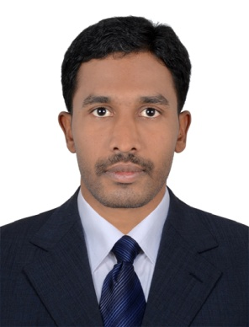
CURRICULUM VITAE

SRINIVAS
Dubai, U.A.E

Email: srinivas.382500@2freemail.com

OBJECTIVE
Seeking a good career and holding a responsible position in the reputed organization and ensure credible performance to work towards exceeding the set goals contributes for the organization.
PROFILES
- Well Know All Location in UAE
- Valid UAE & Saudi Arabia Driving License Holder
- Hard working and dedicated
- Good communication and analytical skills
- Can work under pressure with time bound performance
- Easy adaptability to situations

EDUCATIONAL ATTAINMENT
- BSC- Degree completed from Kakathiya University 2009-2012
- PLUS TWO 2007-2009
- SSC 2006-2007
COMPUTER QUALIFICATION
- PGDCA - 1 YEAR COUSRE COMPLETED
- MS OFFICE
- INTERNET & EMAIL
WORK EXPERIENCE

Name of the Organization : GINNY’S DMCC, Dubai, UAE
Duration : Oct 2017 to Present
Position held : Driver

Name of the Organization : Trans Classic LLC, Dubai, UAE
Duration : Dec 2013 to Oct 2017
Position held : Sales Executive cum Driver

Name of the Organization : Yazaid Faleh al Qahtani, Saudi Arabia
Duration : April 2012 to Sep 2013
Position held : Heavy Driver

UAE DRIVING LICENSE DETAILS
Date of Issue : 19/03/2015
Place of Issue : 19/03/2025
License Type : Light Vehicle ( Manual)
Please of Issue : Dubai, UAE

PERSONAL DETAILS
Date of Birth : 10/11/1988
Gender : Male
Nationality : Indian
Marital Status : Married
Language Known : English, Arabic, Hindi

PASSPORT DETAILS
Date of Issue : 17/10/2017
Date of Expiry : 16/10/2027
Visa Status : Employment Visa

DECLARATION
I hereby declare that the particulars furnished above are true to the best of my Knowledge and belief

