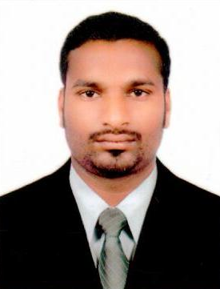
CURRICULUM VITAE

ANJAIAH
DUBAI – U.A.E

E-mail: anjaiah.382501@2freemail.com

Career Objectives
My objectives is to be ultimately a better human being which I believe can be achieved by working in an environment involving continuous learning and challenging situation in very friendly and positive manner .

Personal Profile

- Hard working and dedicated
- Sincere and result oriented
- Can work under pressure with time bound performance
- adaptability to situations
- Good communication and analytical skills
- All Knowledge of Dubai Road Locations
Educational Qualifications
- S.L.L. C ( Secondary School Leaving Certificate )
Computer Qualifications
- Basic Knowledge of Computer
Employment History
- Presently working as a Delivery Boy/ Messenger in Mara-Ison Technologies LLC ( Home Satisfaction Cleaning Services Dubai UAE from Jan 2016 to till date

Personal Details
Nationality : Indian
Date of Birth : 01/01/1992
Gender : Male
Marital Status : Single
Languages Known : English, Hindi & Telugu

Passport Details
Date of Issue : 10/12/2014
Date of Expiry : 09/12/2024
Visa Status : Employment Visa

Driving License Details
Date of Issue : 12/09/2017
Date of Expiry : 12/09/2019
Place of Issue : Dubai
License Type : Motorcycle

Declaration

I hereby declare that the above information are true and correct to the best of my knowledge and belief.

