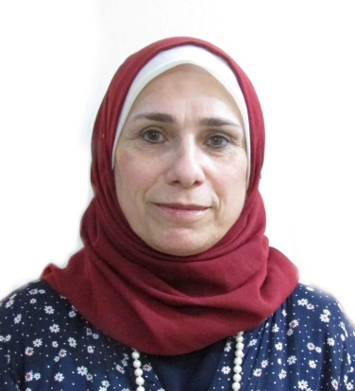
Tahrir
B.Sc. Statistics – University of Baghdad
College of Administration and Economics

tahrir.382505@2freemail.com

Personal Information

Nationality : Iraqi
Date of Birth : 12/07/1959
Marital Status : Married.

Career Aim

With more than 16 years of professional experience in the field of teaching Mathematics, I desire to move to a more challenging work environment in a major establishment where I can put my experience into full use.

Work Experience

2011 – 2018 | Mathematics Teacher  Al-Mansour Secondary School (Private Sector)  Baghdad - Iraq  Grades 10, 11 & 12 and summer tutorial classes for Grade 12
2008 – 2011 | Mathematics Teacher  Yemen Modern School (Private Sector)  Sana‘a - Yemen  Grades 10, 11 & 12 AS level & IGCSE and Governorate Curriculum
2005 – 2008 | Mathematics Teacher  British International School (Private Sector)  Sana‘a - Yemen  Grades 10, 11 & 12 AS level & IGCSE and Governorate Curriculum
2002 – 2005 | Mathematics Teacher  Al-Amjad Secondary School (Private Sector)  Sana'a - Yemen  Grades 10, 11 & 12 AS level & IGCSE and Governorate Curriculum
1981 – 1993 | Computer System Analyist and Programmer  Ministry of Trades  Baghdad - Iraq

Education
1977 – 1981 | B.Sc. Statistics  University of Baghdad – Collage of Administration andEconomics  Baghdad - Iraq

Key Achievements

- Member in Iraqi Teachers Union
- Translation of Arabic Mathematics Text Books for Grades 7, 8, 9 & 12 into English.

Language Skills

English | Very good
Arabic | Mother tongue

Computer Skills

Programming languages | COBOL
Microsoft-Office | Word, Excel and PowerPoint
Other Softwares | MathCad and MathType

References

Available upon request.

