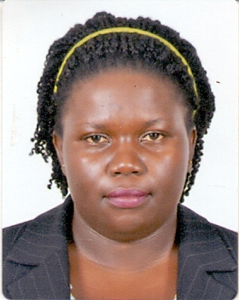
Personal Information:
Nationality: | Ugandan
Gender | Female
Date Of Birth: | 03 May 1983
Address: | Al Rigga, Dubai
Marital Status: | Single
Visa Status | Visit Visa
Academic qualification | Bachelor’s Degree in Education
Languages | English
Position of interest | OFFICE ADMININSTARATION

- A versatile Multifunctional professional with a zeal to widen her career to the top.
- A self-motivated person who enjoys taking on different challenges in life and a reliable team player.
- Quick at learning and grasping new concepts especially with the ever changing times of technology. Enjoys working as team, creating new relationships and extensive knowledge acquisition.
Employment Background
Organization Year Position
Uganda Australian Foundation 2006-2007 Teaching Assistant
ABC Children’s Aid 2007-2009 Child Protection Officer/Teacher
Central college Mityana 2010-2017 Teacher
NUDIETS 2018 Consultant
Skills and Competences:
- Great communication skills (verbal and written)
- Great team player with people of different national and international backgrounds.
- Mastery of Microsoft Office programs (Word, Excel, PowerPoint)
- Ability to work under minimal supervision and under pressure
- Good at building new relationships across different across different organization levels
- Ability to pay attention to great detail
Certification
I certify that all the above information is true and you are free to contact any of my referees

