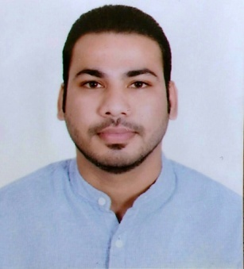
CURRICULAM VITAE

Amit

E-mail - amit.382516@2freemail.com

OBJECTIVE
Seeking to work in a dynamic environment in team where I can put my innovative& constructive ideas and could contribute for attaining organization goals.

WORK EXPERIENCE

ASH TECH MACHINERIES PVT. LTD. COIMBATORE, TAMILNADU, India.
Working in ASH TECH MACHINERIES PVT. LTD. as a Service Engineer.
Since 2015-2016.

Job Profile:
1. Service Engineer
2. Seles Engineer.
3. Maintenance Engineer.

MAA GAYATRI AGENCIES, JABALPUR (M.P) India
Working in MAA GAYATRI AGENCIESas a Production engineer.
Since 2014-2015.
Job Profile:
1. Senior Production Analysis.
2. Maintenance Engineer.

MAA TARA INDUSTRIESPVT. LTD ,JABALPUR (M.P) India
Working in MAA TARA INDUSTRIESPVT. LTD.as a Production Engineer
Since 2013-2014.
Job Profile:
1. Production Analysis.
2. Team handling.
3. Quality control.
4. Document handling.

TECHNICAL SKILL
- Lath Machine
- Grinding Machine
- Drilling Machine
- Gas Welding
- Welding Machine

*Operating System : Window 98/2000/XP/W7/W8.
*Key Skill : Auto Cad Design.

QUALIFICATION SUMMRY
Degree | College/School | University/Board | Year Of Passing | Aggregate
B.E  (Mechanical Engg.) | Vindhya Institute Of Technology & Science, Jabalpur (MP) | Rajeev Gandhi Technical University, Bhopal. | 2012 | 70 %
12th | Khalsa H. Sec School Sadar Jabalpur. | M.P. Board | 2007 | 55 %
10th | SaraswatiShikshaMandirGupteshwer road Jabalpur. | M.P. Board | 2005 | 78 %

TRAINING UNDERGONE:

INDUSTRIAL-TRAINING:
    - I have done my Major training from -RANI AVANTI BAI SAGAR BANDH YOUGNA (Hydro Power Plant Bargi)

    - I have done Minor training from NARMADA GELATINE Pvt. Ltd. JABALPUR .

Nationality | :  : | Indian
Hobbies | : | Bike Riding, Visiting New Places, Making New Friend
Strengths | : | Leadership, Quick Learner, self motivation.
Date of Birth  Languages Known | :  : | 1st Dec. 1987.  English, Hindi

PERSONAL PROFILE:

DECLARATION:
I here by declare that the above information furnished by me is true tothe best of my knowledge.

Place: Dubai

