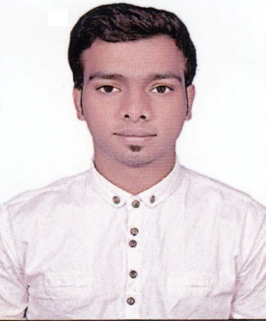
Shaikh
Email: shaikh.382530@2freemail.com

Post Applied for: DRIVING
OBJECTIVES
To get a growth job in a professional environment that provides me learning opportunities and offers a chance to utilize my core competence. I am Competent and hardworking with excellent organizational skills and methodical approach to responsibilities.
WORK EXPERIENCES

Shopper shop , Mumbai-India 2014 – 2015
SALESMAN
Uber; Mumbai-India 2016- 2017
DRIVING
First central hotel apartment Dubai 02/02/2017-16/05/2017
ROOM ATTENDANT
CURRENTLY WORKING IN
Canal central hotel ( five star) Dubai
TEAM LEADER (housekeeping department)
Dubai Driving licence issue date Dec /2017

Job Description
- Greet customers as they enter and offer assistance.
- Provide advice on different products.
- Assist customers in making selections.
- Demonstrate product features to facilitate decision making.
- Ensure that all product deliveries are made on time.
- Maintained inventory of marketing literature.

ACADEMIC QUALIFICATION

- Matriculation
PERSONAL INFORMATION
Date of Birth : 16/05/1997
Nationality : Indian
Marital Status : Single
Visa Status : Employment Visa
Languages : English / Hindi / Urdu

PERSONAL ATTRIBUTES
- Exceptional ability to communicate verbally and in writing
- Able to work in a team fostered environment
- Excellent organizational skills
- Good knowledge of basic mathematical calculations
- Team player
- Strong analytical skills

