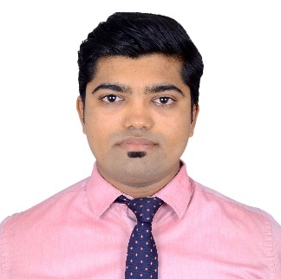
Saurabh

Email: saurab.382547@2freemail.com

Objective:
SeekingOpportunity in a progressive organization that provides ample opportunities to develop and use my skills for growth in the Sales and Marketing vertical.
skills:
Sales,Communication,Team Work, Problem Solving Ability, Self-motivated,Creativity.
Experience:
Currently Working as Senior Sales Executive with Exclusife Technosoft Pvt Ltd. From October’2017
Dealing with SME Sector into CRM Concept.Concept Selling in I.T. Product.
Workedwith Axis BankasPriority Banking Relationship Manager (Assistant Manager)from August’16 to September’17 Main Role wasSales and Services.
Used to Handle HNI Clients into Banking Services for Priority segment.
Investment Counselling, Creating Investment Portfolio, Managing Portfolio.
Operating Sales of Products-Saving Account, Mutual Fund, Life Insurance, General Insurance, other Products and Services.
Worked as Management Traineewith Nielsen India Pvt. Ltd. from May’15 to July’15.
Summer Internship Project: Customer satisfaction index for after sales service of two wheeler.
Winter Internship Project: Brand Building: Patanjali.
Qualification:
Degree | Institute/University/College | Year | Class
M.M.S  (Marketing) | Dr. V. N. Bedekar Institute of Management Studies, Thane  (Mumbai University) | June’16 | First
B.Sc (Comp.Sci). | Dr. BabasahebAmbedkarMarathwada University | March’13 | First
HSC | Deogiri College (Maharashtra Board) | Feb’10 | Second
SSC | Bal DnyanMandir (Maharashtra Board) | March’08 | First

Additional Qualification:
- Certificate Programme in Developing WPF and ASP.NET.
- Certificate in Oracle Database 10g.
- German Language Certifications AI, AII, BI Level of European Framework.
- NISM Certification.
- IRDA Certification .(SP License)

Rewards and recognition:

- Consistently Achieved Performer of the Month for January, February, April.
- Hero of the Month for March and May.
- Pan India top performer for all above Months.
- Also Qualified For JFM Contest -Bangkok Trip.

Extra-Curricular Activities:
- Participation in National level Video Gaming Competition.
- Participation in Poster Making Competition.
- Participated in Escorting committee in Operation Summit.
- Participated in Video Making committee in Finance Summit.
- Former Member of College placement Committee.

Software Skills:
MS-Office, .NET Technology, ORACLE
Personal Details:

Languages Known : Marathi, Hindi, English and German (Deutsch).
Birth Date : 26th March, 1993
Gender : Male
Nationality : Indian

