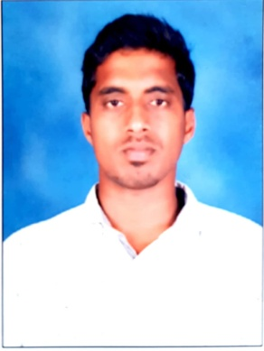
VINOTH
CIVIL / STRUCTURAL ENGINEER,
E-mail: vinoth.382559@2freemail.com

CAREER OBJECTIVE

Seeking to continue the professionalism, where my dedication and talent will definitely help the organization in attaining its goals. Having the ability to provide support for multiple concurrent priorities. Aspiring for a challenging position to contribute to the organizations growth and in turn ensuring personal growth

PROFESSIONAL EXPERIENCE

1. Company: Emirates Heavy Engineering, UAE.
Duration: Nov2017 to present.
Project: G+2 Accommodation, Office Building & Ware House.
Position Held: Project Engineer.

2. Company: Sobha Developers pvt, India.
Duration: May 2016 to Oct 2017. 1 year 5 months.
Project: G+20 Residential Buildings,& G+12 Commercial Building.
Position Held: Senior Engineer.

3. Company: Linea Properties, India.
Duration: May 2013 to May 2016. 3 years
Project:G+6Residential Buildings.
Position Held: Site Engineer.
ROLES AND RESPONSIBILITIES

-Assign work to employees, using material and worker requirements data.
-Analysing reports, drawings, blue prints to plan projects.
-Setting out Project works in accordance with Drawings & Specification.
-Checking of the safety of workers and others at the site.
-Checking that all the technical equipment are in good working condition.
-Assist the Project manager in various assignments
-Coordinating with the other staff as per requirement.
-Maintaining the daily and monthly reports of working.

PROFESSIONAL QUALIFICATION

- Bachelor of Civil Engineering Graduate in the year 2013 Indira institute of engineering & technology Anna University,Tamilnadu, India.

- Completed Diploma course in Building design certified by CADD Centre, Tamilnadu, India.
TECHNICAL SKILLS AND KNOWLEDGE
-AutoCADD, Archi CADD.
-MS office, MS excel.
-Quantity Surveying & Quality Control.

STRENGTH/PERSONAL SKILLS
-Quick learner and a team leader.
-Positive, Sincere, goal-oriented and good adaptability.
-Problem-solving, effective pressure dealing and logical decision-making skills.
-Good analytical and communication skills.

PERSONAL DETAILS

Date of Birth : 25/06/1991
Gender : Male
Marital status : Single
Nationality : Indian
Languages known: English, Hindi, Tamil,& kannada

PASSPORT DETAILS

Place of Issue: Chennai, Tamil Nadu, India.
Date of Issue: 01/06/2017
Date of Expiry: 31/05/2027

DECLARATION
I, hereby declare that above mentioned information is true to the best of my knowledge &belief.
(Vinoth)

