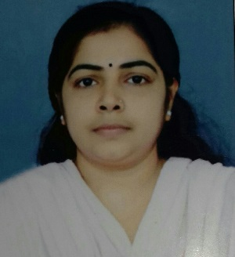
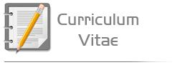

Remya
Medical Transcriptionist/ Data Entry Operator

Email: remya.382573@2freemail.com

Career Objective:

I look forward to work with an organization which offers a challenging opportunity to enhancing my Knowledge, skills and experience that would allow me to contribute towards achieving the organizational goals to the best of my potential.

Key Skills:
• Knowledge of anatomy, physiology medical terminology with various medical specialties as required.
• Good organization and prioritization skills.
• In depth knowledge of medical transcription procedures, guidelines and practices.
• Strong ability of understanding diverse accents, dialects and varying dictation styles.
• Self-motivated, proactive & hardworking.
• Fully aware of all Health & safety legislation
• Accept and adhere to the need for strict confidentiality.
• Ability of working and communicating in a cooperative and positive manner with management, supervisory staff, co-workers.
• Maintaining the official records.
• Fully organized with filing system.

Computer Skills

• Substantial knowledge of MS-Word, Excel, PowerPoint.
• Windows-7 & 8

Educational Qualification:

• 1996 to 1998 _ Having Completed the Vocational Hire Secondary Course in Office Secretary ship.
• 1998 to 1999 _ Having Completed the Board of Apprenticeship Training for Office Secretary ship
/Stenography in Southern Region- Chennai 600 113.
• 2010 to 2011 _ Having Completed the Medical Transcription course from, Bishop Jerome Vijnana VIhar, Kollam.

Professional Experience:

1. Medical Transcriptionist (80 above words per minute typing speed)
Organization: Dovlin Health Care, Kochi.
Duration: July 2012 to till now
2. Post: Data Entry Operator
Organization: Affiliated Computer Services [ACS], Kochi.
Duration: 2011 to 2012

3. Post: Stenographer at Hindusthan Machine Tools (HMT) Ltd., Kalamassery, Ernakulam
Duration: 1998 to 1999.

Roles and Responsibilities:

- Able to contribute in practical ways to the success of my team and to hospital targets.
- To maintain environmental, safety and infection control standards.
- Ability to respond quickly to emergencies.
- Extensive medical transcription experience.
- Superior facility in interpreting and transcribing a wide array of medical specialty reports.
- Strong knowledge of medical language and transcription practices and guidelines.
- High orientation to written and numerical detail.
- Exceptional skills in interpreting recognizing and evaluating discrepancies and inconsistencies in medical texts.
- Good knowledge of physiology and anatomy.
- To transcribe the recorded material, this includes discharge summaries, patient history,
Operative reports, physician letters and notes, rehabilitation, autopsy, pharmacy and x-ray reports.
- Collecting statistical data for analyzing departmental productivity.
- To maintain environmental, safety and infection control standards.
- Distributing and collecting dictation and transcribed reports.
- Following up on physicians' missing and late dictation.
- To sort, copy, assemble, prepare and file records and charts.

Personal Profile:
- Name of Staff: |  | Remya
- Date of Birth:  - Marital Status:  - Nationality:  - Languages: |  | 31 May 1981  Married  Indian
 | Languages: |  | Speaking | Reading |  | Writing
 | English |  | Excellent | Excellent |  | Excellent
 | Hindi |  | Excellent | Excellent |  | Excellent
 | Malayalam |  | Excellent | Excellent |  | Excellent

- Certification

I, the undersigned, certify that to the best of my knowledge and belief, this CV correctly describes myself, my qualifications, and my experience. I understand that any willful misstatement described herein may lead to my disqualification or dismissal, if engaged.

Date: Remya

