curriculum vitae
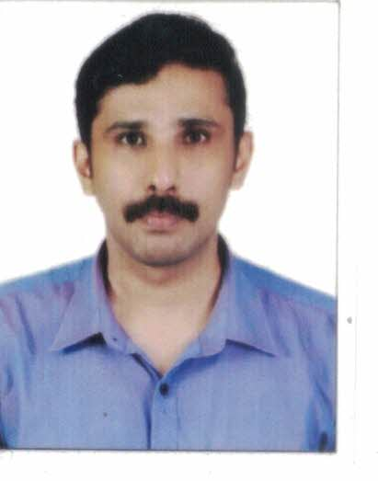
MIDHUN

Email: mithun.382605@2freemail.com

OBJECTIVE

To seek out a challenging opportunity to utilize my functional and technical skills and to be a part of an organization where my creativity, hard work and sincerity are recognized and well rewarded.

PERSONAL STRENGTH

- Possess excellent management communication and interpersonal skills.
- Possess a pleasing personality.
- Quick learner and result oriented.
- Hardworking, energetic, fast and sincere.
- Motivation skill.
- Leadership skill.

PROFESSIONAL EXPERIENCE – 12 years

- Working as computer Hardware technician in GURU INFOSYS( HP WORLD) Calicut

- Worked as service engineer (ATM CAMERA)in NAV SYSTEMS Chennai Since January 2010.

- Worked as service engineer (Hardware & Networking) inFOCUZ COMPUTERS, A multibrand showroom for desktop and laptop. From March 2009 to December 2009.
- Worked as service engineerin NAV SYSTEMS Chennai. From January 2008 to February 2009

- Worked as Computer hardware technicianin GURU INFOSYS( HP WORLD) Calicut from March 2002 To December 2007.

- APPRENTICESHIPin BPL Computers Palakkad. from December 2001 to February 2002

- APPRENTICESHIPComputer Plus Calicut, from August 2001 to November 2001

AREAS OF EXPERTISE

- Systems Administration..
- Installation and serviceing of (IP) DOME CAMERA.
- Troubleshooting/Problem Solving.
- Self KIOSKMechine
- Client Technical Support.
- CCTV
- Configuring, Managing Microsoft
- Installing third party software in windows environment.
- Maintaining all kind of desktop and laptop.
- Providing Internet connections among the privileged systems.

ACADEMIC PROFILE

- BBACOMPUTER APPLICATION (TNOU)

- DIPLOMA IN APPLIED ELECTRONICS AND COMPUTER HARDWAREMAINTANANCE.. AT UNIVERSAL COLLEGE, CALICUT

- SUCCESSFULLY COMPLETED A COURSE ON HARDWARE AND NETWORKMAINTENANCESEEMOS COMPUTERS, CALICUT.

- SUCCESSFULLY COMPLETED A COURSE MCSA(MICROSOFT CERTIFIRD SYSTEM ADMINISTRATOR).

PERSONAL INFORMATIONS

DOB : 03-03-1981
Marital Status : Married
Languages Known : English, Malayalam,Tamil
Nationality : Indian
Religion : Hindu
Visa status : Visit Visa (90 days)

DECLARATION

I hereby declare that the above produced informations are true and correct to the best of my knowledge and belief.

