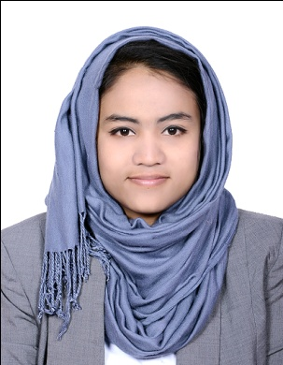
RAJEENA.

rajeena.382609@2freemail.com

Career Objective:

To excel the carrier and to work for an organization where my skills, creativity and knowledge can be utilized in maximizing the organization profits while providing career advancement opportunities.

Work Experience& Responsibilities:

- Admin Assistant (Project Coordinator) in the Project departmentof MAJID AL FUTTAIM FASHION LLC, Dubai.
- Handling the project coordination of Fashion projects in KSA, Qatar, and Kuwait etc.
- Making Purchase Requisitions in Microsoft Dynamics AX.
- Coordinating with the Finance and vendors for the payments.
- Uploading quotation invoices and contracts in system.
- Process incoming and outgoing documents.
- Make sure that controlled copies of latest approved documents are distributed internally.
- Making invoices by using software.
- Executive Document controllerin Supply chain department ofShalina Healthcare DMCC, JLT Dubai (September 2015 to August 2016)
- Implement and maintain document control process and procedures.
- Maintain and manage electronic and hard copy documents as required.
- Process incoming and outgoing documents.
- Make sure that controlled copies of latest approved documents are distributed internally and externally (Clients and Suppliers).
- Making invoices by using software.
- Data entry operator cum Coordinatorin CRM department of Aster DM Healthcare, Dubai(December 2014 to August 2015).
- Data entry of all kind of forms- Survey and Feedback.
- Maintaining of Feedback boxes.
- Maintaining and ordering of both physical stocks and office stationery.
- Making reports for daily weekly and monthly basis.
- Controlling and maintaining of invoices.
- Documents controller of medical records and administration records in Bharat Rural Hospital and Training Centre, Ernakulam, India (July 2013 to August 2014)
- Maintaining both medical and administrative records.
- Maintaining of attendance of staffs.
- Process incoming and outgoing documents.
- Make sure that controlled copies of latest approved documents are distributed internally and externally.

Professional Qualification:

Completed three years Aircraft Maintenance Engineering Course in Avionics stream from Sha-Shib Aviation Academy, Cochin, Recognized by DGCA, Government of India and six months on the job training from Hindustan Aeronautics Limited, Accessories division Lucknow.

Practical Achievements

- Familiarized to the component of LEARJET 25B
- Familiarized to the component of CESSNA 150-JA
- Six months on the job training at Hindustan Aeronautics Limited, Accessories division Lucknow, India.

Professional Goal

- To make a successful carrier and to move upward along with way through sheer dedication and hard work.
- To excel is assigned responsibilities and thereby ensure professional and personal growth and aspirations of organization.

Personal Data:

Date of Birth : 08-02-1992
Gender : Female
Nationality : Indian
Marital Status : Married
Religion & Cast : Islam Muslim

Declaration:

I hereby declare that all the information’s given above are tare true and correct with the best of my knowledge and I bear the responsibility of the above-mentioned particulars.

