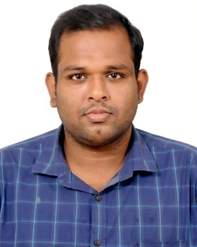
SARAVANA

e-mail id : saravana.382612@2freemail.com

Objective

Aiming to work for a dynamic organization that extends opportunities for extensive learning and skill enhancement to all its employees , by fostering a professional environment. I see myself contributing effectively to such an organization’s goals through responsible leadership and by setting high professional standards.

Academic Qualification

- B.Sc ( Information Technology ) Bharathithasan university Trichy - 2011 passed out
- Higher Secondary Tamilnadu State board - 2006 passed out

Professional Experience

Company Name : Accenture Solutions Pvt Ltd
Location : Chennai , India
From : December 2011 - September 2017
Designation : Senior Process Associate

Profile synopsis

- Handling health insurance claims process for one of the leading U.S health insurance company
- Maintain and prepare documents on daily basics.
- Document billing on target based.
- Adjudicating of HCFA & UB Claims and generating the bill payment to appropriate billing provider
- Identification of bill types on the speciality , service provided & procedure codes
- Analyzing the medical services with available procedure codes ( i.e : Office Visits , PT, OT , Surgery , Emergency )
- Handling both paper claims and the electronic claims
- Handling medical claims , Enrolled members , medical billing
- Daily delivery of claims by coordinating with multiple associate
- Assisted quality team in developing and maintain
- Meeting customer SLA ( TAT & Quality )
- Provide monthly training with support analysts to increase knowledge and skills
- Having experience in auditing claims
- KP proficient in Tapestry Core & Tapestry AP Claims & Contracts EPIC 2014
- Allocating work to team and internal QC for the team
- Training the new associate in the process
- Periodically training on new updates
- Daily webex calls with onshore team and client

Additional Skills

- EMR Applications Hands On – EPIC Tapestry ,
- Facets , Citrix , Ultera
- Computer hardware and networking

Personal Details

Date of Birth : 03-07-1988
Sex : Male
Nationality : Indian
Marital Status : Married
Languages Known : English, Tamil
Visa Status : Visit Visa
Valid Driving License : India

Declaration

I here by declare that the given above information are true to the best of my knowledge and belief and can be supported with reliable documents when needed.

