RESUME
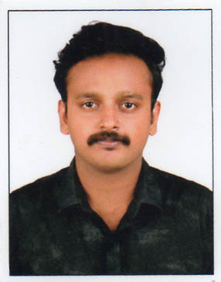

Objectives

To enhance my educational and professional skills in a stable and dynamic workplace.

Educational qualification

Course | College / School | University | Year of pass
M.COM | St.Joseph Management Institute of Devagiri | Calicut | Currently pursuing
B.COM | St.Joseph Management Institute of Devagiri | Calicut | 2015
Plus Two | M.C.C.G.H.S.S | - | 2012

Professional qualification
- Tally Version 9.0
- VAT – Value Added Tax

Work experience
Assistant Store Manager -PEOPLE Store - Jan 2017-Jan 2018
Sales Executive - Park AvenueStore - May 2015-Dec 2016

Responsibilities
- Cash handling
- Preparing daily sales report
- Maintain agreed guidelines and standards for Visual Merchandizing
- Achieve company sales target

Personal details
Name : ARJUN
Marital status : Married
Date of Birth : 10th October 1994
Email : arjun.382633@2freemail.com
Languages : English, Malayalam ,Hindi

Declaration
I hereby declare that all the information stated above is true to best of my knowledge and belief.

